

Artificial Intelligence-Based Predictive Modelling for Early Detection of Thyroid Disorders
A Comparative Study of Machine Learning & Deep Learning Algorithms

Vempa Venkata Sai Gopi - 240074926

Submitted in accordance with the requirements for the degree of
Master of Science in Computer Science

Under the Supervision of
Ms Lakmali Karunarathne
Department of Computer Science, York St John University

York St John University
London Campus
Department of Computer Science

January 2026

ABSTRACT
Thyroid disorders, including hypothyroidism and hyperthyroidism, affect a significant portion of the global population and, if left untreated, can lead to severe metabolic, cardiovascular, and psychological complications. Early detection is crucial for timely intervention and improved patient outcomes. However, conventional diagnostic techniques relying on threshold-based interpretation of thyroid hormone levels (T3, T4, and TSH) often fail to identify subclinical or early-stage cases. This study aims to leverage Artificial Intelligence (AI) and Machine Learning (ML) techniques to develop predictive models capable of detecting thyroid disorders with greater accuracy and reliability. Multiple supervised learning algorithms—such as Logistic Regression, Random Forest, Support Vector Machine (SVM), K-Nearest Neighbors (KNN), Artificial Neural Network (ANN), XGBoost, and CatBoost are implemented and evaluated on thyroid datasets to analyze their predictive performance. Various data preprocessing techniques, including normalization and feature scaling, are applied to ensure data consistency and enhance model learning efficiency. The comparative analysis focuses on determining the best-performing algorithm based on accuracy, F1-score, recall, precision, and ROC-AUC metrics. Ensemble-based and deep learning algorithms outperform traditional models in capturing complex patterns and non-linear relationships among features. This comprehensive evaluation provides insights into algorithmic behavior across different data distributions, highlighting the strengths and limitations of each model.The proposed research introduces a hybrid AI model that integrates an Artificial Neural Network (ANN) and CatBoost to predict thyroid disorders efficiently. The ANN, built using scikit-learn’s MLPClassifier, is employed for deep feature extraction to learn complex relationships among clinical attributes, while the CatBoost classifier is used for robust and interpretable classification. The hybrid model outperformed traditional algorithms such as Logistic Regression, Random Forest, and Support Vector Machine (SVM) in terms of accuracy, precision, and recall. The results demonstrate the superior capability of the hybrid model, Ensemble-based and deep learning algorithms in identifying early thyroid dysfunction, even in cases where biochemical indicators appear borderline. This research contributes to the growing field of AI-driven diagnostics and highlights the potential for integrating predictive analytics into clinical workflows. Such an approach can aid healthcare professionals in achieving early diagnosis, improving patient outcomes, and facilitating personalized medical care through intelligent, data-driven insights.
Keywords:
Artificial Intelligence (AI), Thyroid Disorder, Predictive Modelling, Machine Learning, Deep Learning, Artificial Neural Network (ANN), CatBoost, Early Diagnosis, Medical Data Analysis, Hybrid Model.

DECLARATION
I hereby certify that this dissertation constitutes my own product, that where the language of others is set forth, quotation marks so indicate, and that appropriate credit is given where I have used the language, ideas, expressions or writings of another.
I confirm that I have not copied material from another source nor committed plagiarism nor commissioned all or part of the work (including unacceptable proof-reading) nor fabricated, falsified or embellished data when completing the attached piece of work.
I declare that the dissertation describes original work that has not previously been presented for the award of any other degree of any institution.
I affirm that the use of AI in this dissertation does not undermine the academic integrity of the work and complies with the regulations set forth by York SJ University. Any assistance provided by Artificial Intelligence (AI) tools, including but not limited to research, writing, or editing, has been acknowledged and utilized in accordance with ethical guidelines.

Signed,
Vempa Venkata Sai Gopi
Date- 28-01- 2026

ACKNOWLEDGEMENTS
I would like to take this opportunity to express my sincere gratitude to all those who have supported and contributed, directly and indirectly, to the successful completion of this dissertation.
First and foremost, I extend my deepest appreciation to my supervisor, Ms. Lakmali Karunarathne, Department of Computer Science, York St John University, for her invaluable guidance, continuous support, and constructive feedback throughout the course of this research. Her expertise, patience, and encouragement played a crucial role in shaping the direction of this study and enhancing its academic quality. Her insightful suggestions and timely reviews helped me to critically evaluate my work and improve it at every stage of the research process.
I would also like to thank the faculty members of the Department of Computer Science, York St John University, for providing a stimulating academic environment and a strong foundation in both theoretical and practical aspects of computer science. The knowledge gained through coursework and discussions significantly contributed to the successful execution of this project.
My sincere appreciation goes to the creators and maintainers of publicly available datasets and open-source tools, particularly the UCI Machine Learning Repository, Kaggle, and the Python data science community. These resources were essential for data acquisition, experimentation, and implementation, and they made it possible to conduct this research in an ethical and reproducible manner.
I would also like to acknowledge the role of modern computational tools and libraries that supported this work, including Python-based machine learning frameworks and visualization tools, which enabled efficient data processing, model development, and performance evaluation.
On a personal note, I am deeply grateful to my family for their unwavering support, patience, and encouragement throughout my academic journey. Their constant motivation and belief in my abilities provided me with the strength and determination to overcome challenges and remain focused on my goals. I am equally thankful to my friends and peers for their moral support, constructive discussions, and encouragement during demanding phases of this work.
Finally, I would like to acknowledge my own efforts and perseverance in completing this dissertation, which has been a valuable learning experience that strengthened my technical, analytical, and research skills. This work marks an important milestone in my academic and professional development, and I am grateful to everyone who contributed to making this achievement possible.

Table of Contents
Title Page i
Declaration ii
Acknowledgements iii
Table of Contents iv
List of Tables v
List of Figures vii
List of Abbreviations viii
01 Chapter 1 : Introduction 1
1.1 Background & Motivation 1
1.2 Problem Statement 2
1.3 Aim of Study 2
1.4 Significance of the Study 3
1.5 Objectives of the Study 3
1.6 Research Questions 3
1.7 Proposed Solution 4
1.8 Research Scope 5
1.9 Research Design 5
1.10 Ethics & Transparency 7
1.11 Research Gap 7
02 Chapter 2 : Literature Review 9
2.1 Introduction 9
2.2 Theoritical Background 9
2.3 Review of Machine Learning Approaches in Thyroid Prediction 10
2.4 Critical Evaluation of Existing Literature 12
2.5 Extended Comparative Analysis of Algorithms 14
2.6 Identified Research Gaps 14
2.7 Justification of Current Study 15
2.8 Feature Selection & Preprocessing 15
2.9 Extended comparative analysis of prior research and current study 15
03 Chapter 3 : Research Methodologies 23
3.1 Overview 23
3.2 SystemRequirements (Software, Hardware, Functional & Non Functional) 23
3.3 Dataset Description & Preprocessing 24
3.4 Machine Learning Algorithms used for Thyroid Prediction 29
3.5 Deep Learning & Hybrid Models used for Thyroid Prediction 34
3.6 Exploratory Data Analysis 37
3.7 Model Evaluation Approach 40
3.8 Work Breakdown Structure (WBS) & Timeline 41
3.9 Gantt Chart 41
04 Chapter 4 : Results and Discussion 42
4.1 Introduction to Results 42
4.2 EDA Results 42
4.3 Model Implementation 42
4.4 Results for EDA & Model wise Implementations 42
4.5 Model Evaluation Metrics 52
4.6 Test Case Analysis 57
4.7 Concluding Discussion of Results 59
05 Chpater 5 : Conclusion, Limitations&Future Recommendations...……………………………...60
5.1 Discussion 60
5.2 Conclusion 60
5.3 Limitations 61
5.4 Future Scope 61
5.5 Future Recommendations 63
References 65
Appendix 68

List of Tables
Table Number | Table Name | Page Number
Table 2.1 | Summary of AI Models in Thyroid Prediction | 12
Table 2.2 | Accuracy table for ML Algorithms | 12
Table 2.3 | Comparative Strengths & Weaknesses of ML/DL Models | 14
Table 3.1 | Dataset Description | 24
Table 3.2 | Work Breakdown Structure | 41
Table 4.1 | Evaluation Table | 53
Table 4.2 | Test cases Observations | 59

List of Figures

Number of the Picture | Page Number
Figure 1 | 7
Figure 2 | 16
Figure 3 | 17
Figure 4 | 19
Figure 5 | 20
Figure 6 | 26
Figure 7 | 26
Figure 8 | 27
Figure 9 | 27
Figure 10 | 28
Figure 11 | 28
Figure 12 | 29
Figure 13 | 29
Figure 14 | 30
Figure 15 | 30
Figure 16 | 31
Figure 17 | 31
Figure 18 | 32
Figure 19 | 32
Figure 20 | 33
Figure 21 | 33
Figure 22 | 34
Figure 23 | 35
Figure 24 | 35
Figure 25 | 36
Figure 26 | 37
Figure 27 | 38
Figure 28 | 38
Figure 29 | 39
Figure 30 | 39
Figure 31 | 40
Figure 32 | 41
Figure 33 | 43
Figure 34 | 44
Figure 35 | 46
Figure 36 | 48
Figure 37 | 49
Figure 38 | 50
Figure 39 | 51
Figure 40 | 52
Figure 41 | 53
Figure 42 | 54
Figure 43 | 54
Figure 44 | 55
Figure 45 | 56

List of Abbreviations
SVM | Support Vector Machine
ML | Machine Learning
DL | Deep Learning
ANN | Artificial Neural Networks
DNN | Deep Neural Networks
SHAP | SHapley Additive exPlanations
GDPR | General Data Protection Regulation
HIPAA | Health Insurance Portability and Accountability Act
KNN | K – Nearest Neighbors

Chapter 01: Introduction
  - Background and Motivation
Thyroid disorders has become a prominent approach in the most common metabolic and hormonal disorders in modern healthcare. As per the World Health Organization (WHO), nearly 750 million people worldwide suffer from some form of thyroid abnormality (Ibrahim et al., 2022), with a significant percentage remaining undiagnosed. Thyroid disorders have become one of the most common endocrine conditions (World Health Organization, 2023). These disorders primarily arise due to imbalances in the production and regulation of thyroid hormones, including triiodothyronine (T3), thyroxine (T4), and thyroid-stimulating hormone (TSH)which regulate metabolism, growth, and energy utilization. Thyroid hormones which are T3, T4 and TSH regulate metabolic and physiological processes (Zimmermann & Boelaert, 2015). The increasing prevalence of lifestyle-related diseases, environmental stressors, and dietary iodine deficiencies have further contributed to the rise of thyroid dysfunctions, making early detection and intervention a global health priority.
Traditional thyroid disorder diagnosis largely depends on laboratory-based assays and physician interpretation of test results. However, these methods often rely on static threshold values of T3, T4, and TSH, which can vary between populations and individuals. Moreover, early-stage thyroid dysfunctions or subclinical cases frequently go unnoticed due to overlapping symptoms with other diseases such as depression, obesity, or fatigue. Subclinical disorders often go unnoticed due to overlapping symptoms (Biondi & Cooper, 2008). This diagnostic uncertainty results in delayed treatment, worsening symptoms, and higher healthcare costs. Hence, there is a pressing need for a more precise, data-driven approach that can detect early deviations in hormone patterns and support taking decisions clincally.
In recent years, Artificial Intelligence (AI) has revolutionized healthcare through its ability to analyze large volumes of medical data and recognize subtle patterns. Machine Learning (ML) and Deep Learning (DL) techniques have been successfully applied in disease detection, patient prognosis, and personalized medicine. AI and ML have demonstrated strong capabilities in medical diagnosis (Esteva et al., 2019). By leveraging algorithms that learn from historical patient data, AI systems can make accurate predictions and uncover relationships that are not immediately visible through conventional statistical methods. Such advancements open up opportunities for using AI-based predictive models to improve the precision of thyroid disorder identification.
This study is motivated by the inherent limitations observed in existing approaches of traditional diagnostic practices and the growing success of AI in medical prediction. ML algorithms like SVM, Random Forest, and Gradient Boosting are widely used in disease prediction (Shailaja et al., 2018), they often lack interpretability and adaptability to non-linear data. Deep learning models like Artificial Neural Networks (ANNs), on the other hand, excel at capturing complex relationships but require high computational resources. Hybrid ML and DL approaches are increasingly used to improve diagnostic accuracy (Chen et al., 2020). Therefore, integrating the strengths of both models ANN’s deep learning capacity and CatBoost’s gradient boosting interpretability can create a robust hybrid system capable of improving diagnostic performance and reliability.
Previous research has demonstrated the potential of ML algorithms in various disease domains such as diabetes, cardiovascular disease, and cancer prognosis. However, comprehensive comparative studies focusing on thyroid disorder prediction remain limited. This gap motivates the need to evaluate the effectiveness of multiple algorithms using diverse model architectures and performance metrics.
The motivation behind this research lies in building a reliable, data-driven system that can complement existing clinical practices. By comparing multiple AI-based predictive models, this study aims to identify the most efficient algorithm for thyroid disease classification, ultimately contributing to more accurate diagnostics, cost-effective screening, and improved patient care.
1.2. Problem Statement
The conventional diagnostic approach for thyroid disorders may fail to detect abnormalities in their early stages, particularly when symptoms are subtle, non-specific, or overlap with other clinical conditions such as fatigue, obesity, or depression (Biondi & Cooper, 2008). Such limitations often lead to delayed detection and treatment, allowing the disorder to progress unnoticed. With thyroid disorders impacting a large segment of the worldwide population, there is a critical need for intelligent systems capable of leveraging complex datasets including demographic, clinical, and biochemical parameters to predict the likelihood of thyroid dysfunction before it becomes clinically apparent (WHO, 2023; Zimmermann & Boelaert, 2015).
However, building accurate AI-based predictive systems for thyroid disease presents several key challenges. Firstly Thyroid datasets are often unevenly distributed, characterised by a higher proportion of disproportionately higher number of normal cases compared to abnormal ones, which can cause predictive models to become biased toward majority classes (Shailaja, Seetharamulu&Jabbar,2018). Secondly, clinical features related to thyroid dysfunction frequently exhibit non-linear and interdependent relationships, which traditional diagnostic methods struggle to interpret effectively (Taylor et al., 2018). Third one is , variations in laboratory reference ranges, population characteristics, diet, medication history, and comorbidities introduce noise and inconsistency into thyroid datasets (Zimmermann & Boelaert, 2015). Fourth, early-stage or subclinical disorders display only slight deviations in hormone levels, making them difficult for conventional rule-based systems to detect with high sensitivity (Biondi & Cooper, 2008). Finally, the lack of interpretability in many ML models limits their acceptance in clinical environments, as healthcare professionals require transparent explanations behind algorithmic predictions (Esteva et al., 2019).
To mitigate these challenges, advanced AI-based predictive techniques offer promising solutions.
Non-linear interactions of significant complexity can occur effectively captured by using powerful algorithms such as CatBoost and Deep Neural Networks, which excel in identifying subtle interactions within clinical data (Dorogush, Ershov & Gulin, 2018; Rajkomar, Dean & Kohane, 2019). Data inconsistency issues can be reduced with robust preprocessing techniques, normalization methods, feature selection frameworks, and cross-validation strategies that enhance model generalizability (Shailaja, Seetharamulu & Jabbar,2018), Sensitivity to early-stage anomalies can be improved by combining ensemble methods with deep learning, enabling hybrid models to detect fine-grained deviations in T3, T4, and TSH hormone levels (Chen, Li & Zhao, 2020). Lastly, interpretability concerns can be solved through explainable AI (XAI) approaches such as SHAP values and feature importance visualizations to provide clinicians with transparent and trustworthy insights (Esteva et al., 2019).
Therefore, the development of a reliable, interpretable, and data-driven AI framework capable of addressing these limitations remains a promising yet underexplored direction. This research aims to design and validate such a system to support clinical decision-making and enhance early detection of thyroid disorders.
1.3 Aim
The aim of this study is to develop an AI-based predictive model for the early detection of thyroid disorders using patient clinical and biochemical data. It seeks to apply machine learning and deep learning algorithms to improve diagnostic accuracy and identify subclinical cases. The ultimate goal is to support early intervention and better clinical decision-making for improved patient outcomes.
1.4. Significance of the Study
This study has both academic and practical significance. Academically, it contributes to the growing field of AI in healthcare, offering a data-driven framework for disease prediction. Practically, the implementation of an AI-based thyroid detection model can be utilised as analytical support system for clinicians, potentially reducing diagnostic delays and improving treatment outcomes. Furthermore, such tools can aid in mass screening programs, especially in resource-limited settings where access to endocrinologists is constrained.
1.5. Objectives of the Study
To address the identified research gaps and achieve the overall aim of this study, a set of clearly defined and measurable objectives was formulated. These objectives were designed to ensure a systematic investigation of artificial intelligence techniques for thyroid disorder prediction, covering all key stages of the research process—from data preparation and model development to performance evaluation and interpretation. By structuring the study around these objectives, the research ensures methodological rigor, reproducibility, and meaningful comparison of multiple machine learning and deep learning models, while maintaining relevance to real-world clinical applications.
The primary objective of this research is to develop and evaluate AI-based predictive models for the early detection of thyroid disorders. Specific objectives include:
- To collect and preprocess relevant datasets containing medical and thyroid-specific data.
- To explore and compare multiple AI/ML techniques for predictive modelling.
- To evaluate model performance using standard classification metrics (accuracy, precision, recall, F1-score, AUC).
- To analyze the most significant predictive features for thyroid dysfunction.
- To design an interpretable and scalable AI-based tool that can assist in clinical decision-making.
1.6. Research Questions
- Can AI-based predictive models reliably detect early signs of thyroid disorders using patient data?
    - Mitigation solution:
      - Use hybrid ML–DL architectures (e.g., CatBoost + ANN) to capture non-linear hormone interactions and subtle deviations.
      - Apply cross-validation and robust evaluation metrics (AUC, sensitivity, specificity) to ensure consistent early-stage detection.
- Which machine learning algorithms offer the best performance for this classification task?
    - Mitigation solution :
      - Compare multiple algorithms (SVM, RF, XGBoost, CatBoost, ANN) using the same dataset and standardized metrics.
      - Use hyperparameter tuning (GridSearch, Bayesian Optimization) to obtain optimal configurations.
- What are the key indicators or features contributing most to early detection?
    - Mitigation solution :
      - Apply feature importance methods like SHAP and permutation importance to identify critical predictors (e.g., TSH, T3, T4).
      - Use feature selection techniques such as RFE or mutual information to reduce noise and improve model clarity.
- How can model interpretability and clinical integration be ensured?
    - Mitigation solution:
      - Use interpretable models (CatBoost feature importance, SHAP explanations) and provide clinician-friendly visualizations.
      - Validate the model with clinical experts and incorporate explainable decision rules for easy adoption in practice.
- How can data imbalance in thyroid datasets be addressed to improve predictive accuracy?
    - Mitigation Solution:
      - Apply resampling techniques (SMOTE, ADASYN, undersampling) or class-weight adjustments to balance rare thyroid conditions.
      - Use ensemble methods that are naturally robust to imbalance (CatBoost, Random Forest).
- How can the developed AI model be generalized across different populations and clinical settings?
- Mitigation Solution:
  - Evaluate models on external datasets or through cross-site validation to test population robustness.
  - Use data normalization, domain adaptation, and noise-handling techniques to reduce dataset variability.
1.7. Proposed Solution
The proposed solution involves developing a comprehensive AI-driven predictive framework that systematically evaluates multiple machine learning and deep learning algorithms for early detection of thyroid disorders. The approach begins with rigorous data preprocessing including handling missing values, normalization, and feature selection—to ensure high data quality and reliability (Shailaja, Seetharamulu & Jabbar, 2018). Various algorithms, including Logistic Regression, Decision Tree, Random Forest, Support Vector Machine (SVM), K-Nearest Neighbors (KNN), XGBoost, CatBoost, and Artificial Neural Network (ANN), are implemented and compared based on their classification performance, as these models have demonstrated strong predictive capability in prior healthcare applications (Esteva et al., 2019; Rajkomar, Dean & Kohane, 2019). The models are trained on patient data containing biochemical and demographic features such as T3, T4, TSH, age, and gender to predict thyroid status (hypothyroid, hyperthyroid, or normal), as these features are clinically recognized indicators of thyroid dysfunction (Zimmermann & Boelaert, 2015; Taylor et al., 2018). Performance is evaluated using standard metrics like accuracy, recall, precision, F1-score, and ROC-AUC to identify the most effective model (Chen, Li & Zhao, 2020). CatBoost and ANN are included due to their ability to handle non-linear patterns and complex interactions within medical datasets (Dorogush, Ershov & Gulin, 2018; Rajkomar, Dean & Kohane, 2019). The outcome of this solution is a data-driven, comparative framework that highlights the strengths and weaknesses of each algorithm and recommends the most suitable predictive model for clinical applications, supporting more accurate and early diagnosis of thyroid disorders (Esteva et al., 2019).
1.8. Research Scope
The research scope further extends to exploring how algorithmic parameters, dataset characteristics, and feature importance collectively influence diagnostic accuracy and reliability in thyroid disorder prediction. Understanding these factors is crucial, as variations in hyperparameters, class imbalance, and feature distributions can significantly impact model behavior and clinical applicability (Shailaja, Seetharamulu & Jabbar, 2018). Additionally, analyzing feature importance provides actionable insights into which biochemical and demographic attributes such as T3, T4, TSH levels, age, and gender contribute most to the early detection of thyroid dysfunction, thereby enhancing model interpretability and building clinical trust (Zimmermann & Boelaert, 2015; Taylor et al., 2018). Future extensions of this research could focus on expanding the dataset by incorporating genomic biomarkers, medical imaging data, or longitudinal patient records, all of which have shown potential in improving disease prediction models through richer and more diverse inputs (Esteva et al., 2019). Furthermore, the development of hybrid ensemble approaches combining machine learning and deep learning techniques may yield superior performance by leveraging the strengths of multiple algorithms in capturing complex, nonlinear patterns within medical data (Chen, Li & Zhao, 2020). Another promising direction includes deploying the best-performing predictive model as an intelligent clinical decision-support tool, enabling endocrinologists to identify thyroid abnormalities earlier and with greater precision. Such AI-driven systems have demonstrated substantial benefits in healthcare by augmenting diagnostic workflows and improving patient outcomes (Rajkomar, Dean & Kohane, 2019).
1.9 Research Design
High-Level Architecture (Text Description)
- Data Source Layer
  - Thyroid dataset (UCI / clinical data).
  - Contains demographic + biochemical features (T3, T4, TSH, age, gender, etc.).
- Data Preprocessing Layer
  - Missing value handling
  - Outlier treatment (if required)
  - Normalization/standardization of numeric features
  - Encoding categorical features
  - Train–validation–test split
  - Class imbalance handling (SMOTE / class weights)
- Feature Engineering & Selection Layer
  - Correlation analysis
  - Feature selection (RFE / mutual information)
  - Feature importance analysis (e.g. from Random Forest, XGBoost, CatBoost)
- Modeling Layer
  - Train multiple models:
    - Logistic Regression
    - Decision Tree
    - Random Forest
    - SVM
    - KNN
    - XGBoost
    - CatBoost
    - ANN
  - Hyperparameter tuning (GridSearch / RandomSearch / Bayesian Optimization)
- Evaluation & Comparison Layer
  - Metrics: Accuracy, Precision, Recall, F1-score, ROC-AUC
  - Confusion matrix per model
  - Model ranking / comparison table
  - Select best-performing model(s)
- Explainability Layer
  - SHAP values / feature importance plots
  - Interpretation of key predictors (TSH, T3, T4, etc.)
  - Generate clinician-readable explanations
- Deployment / Decision-Support Layer (Future Work)
  - Wrap best model as an API (Flask/FastAPI)
  - Integrate with a simple UI or hospital system
  - Use as a decision-support tool for endocrinologists

Flowchart of the Architecture:
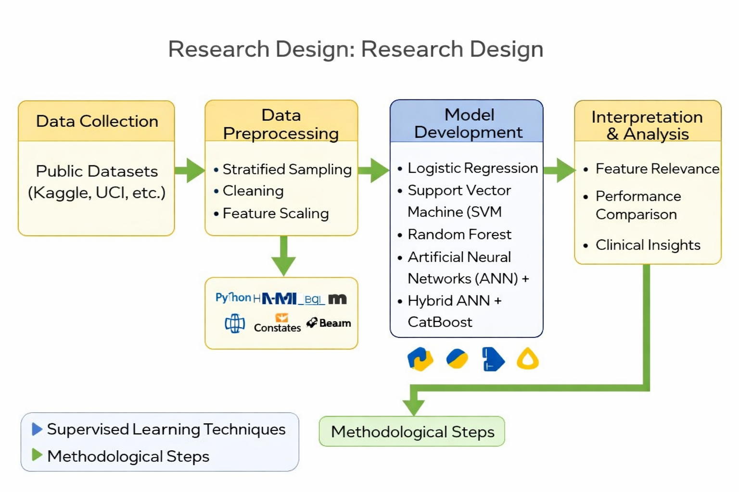
Figure 1:(Flowchart, 2025)
1.10 Ethics and Transparency:
To guarantee responsible behavior and results, a number of ethical issues must be resolved in the research project centered on Artificial Intelligence-Based Predictive Modelling for Early Detection of Thyroid Disorders. Bias and fairness in data are significant concerns. The dataset used may include demographic factors such as age, gender, or ethnicity, which could introduce biases if not properly handled. To mitigate this, careful data preprocessing and the use of fairness-aware algorithms will be critical to avoid discriminatory predictions. The transparency of AI models are vital, particularly in healthcare applications where decisions may directly impact patient care
1.11 Research Gap:
Although significant progress has been made in applying artificial intelligence techniques to medical diagnosis, several gaps remain in the context of thyroid disorder prediction. Existing studies predominantly focus on the application of individual machine learning models or limited combinations of algorithms, often without a systematic comparative evaluation across multiple approaches. As a result, there is insufficient evidence regarding the relative effectiveness of traditional machine learning, deep learning, and ensemble models when applied to the same thyroid dataset.
Furthermore, many prior works primarily address binary classification problems and overlook early-stage or subclinical thyroid disorders, which are more difficult to detect due to subtle hormonal variations. This limits the clinical usefulness of such models, as early detection is critical for timely intervention and improved patient outcomes.
Another notable gap lies in the limited exploration of hybrid modelling techniques that integrate the strengths of deep learning and ensemble learning. While deep neural networks are effective at capturing complex non-linear relationships, they are often used in isolation, without leveraging complementary models that could enhance robustness and generalisation.
Additionally, existing research often provides minimal discussion on feature relevance and interpretability, reducing clinical trust and limiting adoption in real-world healthcare settings. There is also a lack of consistent evaluation using multiple performance metrics and real-world data preprocessing strategies, such as handling class imbalance and noise.
Therefore, there is a clear need for a comprehensive, comparative, and interpretable AI-based framework that evaluates multiple machine learning and deep learning models, incorporates hybrid approaches, focuses on early detection, and aligns predictive outcomes with clinical relevance. This research aims to address these gaps by proposing a robust and data-driven predictive modelling approach for early thyroid disorder detection.

Chapter 02: Literature Review
2.1 Introduction
Early detection of thyroid disorders has long been a challenge due to the often asymptomatic nature of early-stage disease. As with growth of artificial intelligence (AI) in healthcare, predictive modelling using machine learning (ML) and deep learning (DL) techniques is showing potential to improve early diagnosis. This chapter reviews the existing literature on thyroid disorder prediction, AI/ML techniques applied to clinical diagnostics, and the use of predictive models in medical decision support.
Thyroid dysfunction, encompassing conditions such as hypothyroidism and hyperthyroidism, affects metabolic processes and is prevalent worldwide (Vanderpump, 2011). Traditional diagnostic methods rely heavily based on the measured serum concentrations of T3, T4, and thyroid-stimulating hormone (TSH) along with clinical evaluation. However, early detection remains difficult due to non-specific symptoms and variations in hormonal thresholds across populations (Biondi and Cooper, 2008).
AI and ML have increasingly been applied in healthcare domains for disease classification, outcome prediction, and diagnostic support. Algorithms such as Support Vector Machines (SVM), Decision Trees, Random Forests, and Neural Networks have been successful in classifying diseases like diabetes, cancer, and cardiovascular conditions (Esteva et al., 2019; Rajkomar, Dean and Kohane, 2019). These models can learn from complex, high-dimensional medical datasets and provide insights beyond human cognitive limitations.
Several studies have explored AI applications specifically for thyroid disorder prediction. (Sahan et al. ,2007) used a combination of k-Nearest Neighbours (k-NN) and a fuzzy logic-based classifier to predict thyroid status, achieving over 90% accuracy. (Polat and Güneş ,2007) applied an adaptive neuro-fuzzy inference system (ANFIS) for thyroid classification and found it effective in handling non-linear data. (Dey et al., 2016) employed decision tree classifiers on UCI thyroid datasets and achieved promising accuracy levels while identifying TSH and age as key features. (Chaurasia and Pal ,2017) compared Naïve Bayes, Random Forest, and SVM classifiers and concluded that Random Forest gave the best performance with an accuracy of 97.6%. (Elazab et al. ,2020) implemented a deep learning model based on convolutional neural networks (CNNs) for thyroid ultrasound image classification, demonstrating the feasibility of DL models in image-based diagnosis.
These studies affirm the effectiveness of AI-based models but often rely on limited datasets or fail to incorporate explainability into model outputs.
2.2 Theoretical Background
2.2.1 Thyroid Physiology and Hormonal Regulation
The thyroid gland synthesises and secretes triiodothyronine (T3) and thyroxine (T4), regulated by the thyroid-stimulating hormone (TSH) from the pituitary gland. These hormones influence:
- Basal metabolic rate
- Cardiovascular functioning
- Neurological development
- Reproductive health
Minor deviations in hormone levels can lead to hypothyroidism or hyperthyroidism, each associated with serious metabolic consequences (Zimmermann & Boelaert, 2015). Subclinical thyroid disorders present a diagnostic challenge because hormone deviations are often mild and may remain within borderline ranges (Taylor et al., 2018).
2.2.2 Limitations of Conventional Diagnostic Methods
Traditional diagnosis is based on laboratory tests, physical examination, and patient history. However:
- Static thresholds vary across populations and laboratories.
- Late-stage symptoms are easier to detect, but subclinical cases often mimic other conditions such as depression or fatigue.
- Manual interpretation introduces subjectivity, reducing diagnostic consistency (Biondi & Cooper, 2008).
- Complex interactions between metabolic markers cannot be precisely captured using linear statistical models.
These limitations suggest that a more dynamic, data-driven approach is essential for timely detection.
2.2.3 Evolution of AI in Healthcare Diagnostics
AI technologies ML, DL, and hybrid approaches have transformed modern healthcare. They enable systems to:
- Process large volumes of medical data
- Detect hidden patterns
- Withstand noise
- Predict clinical outcomes
- Support decision-making
AI has been successfully applied in diabetes, cardiovascular disease, cancer prognosis, respiratory disorders, and hormonal abnormalities (Rajkomar, Dean & Kohane, 2019). Its integration in thyroid diagnostics is comparatively new but growing rapidly.
2.3 Review of Machine Learning Approaches in Thyroid Prediction
2.3.1 Logistic Regression (LR)
Logistic Regression is a classical statistical classifier widely used in early thyroid studies. Its strengths include interpretability and ease of implementation. However, its predictive capability is limited when dealing with nonlinear relationships within hormonal datasets (Esteva et al., 2019). Most thyroid datasets exhibit:
- Multicollinearity
- Hormonal interactions
- Nonlinear distributions
LR struggles under such conditions and demonstrates lower accuracy (70–80%).
2.3.2 Decision Trees (DT)
Decision Trees provide rule-based classification and offer transparency in medical contexts. Studies show DTs can classify thyroid abnormalities reasonably well but tend to overfit small datasets (Shailaja et al., 2018). Their performance decreases significantly with noisy or imbalanced classes.
2.3.3 Random Forest (RF)
RF improves decision tree performance through bagging and ensemble learning. It offers higher accuracy (>90% in several studies), handles missing values, and provides feature importance analysis (Chen, Li & Zhao, 2020). However, RF still struggles with class imbalance, which is common in thyroid datasets where normal cases dominate.
2.3.4 Support Vector Machines (SVM)
SVM is widely applied in biomedical classification due to robustness in high-dimensional spaces. It is especially effective for binary classification tasks. Studies consistently report SVM accuracy between 85–90% for thyroid prediction (Shailaja et al., 2018). Its limitations include computational complexity and lack of interpretability.
2.3.5 K-Nearest Neighbours (KNN)
KNN is simple and non-parametric but highly sensitive to feature scaling and noise. It performs moderately well when preprocessed datasets are used (75–88% accuracy). It does not generalize well for large or noisy thyroid datasets.
2.3.6 Gradient Boosting Models (XGBoost)
XGBoost is known for high classification accuracy and computational efficiency. It handles missing data, interactions, and noisy features. Research shows XGBoost generally outperforms RF and SVM in thyroid diagnosis, reaching 90–93% accuracy (Dorogush et al., 2018). However, it requires extensive hyperparameter tuning and may overfit if not regularized properly.
2.3.7 CatBoost
CatBoost is a modern gradient boosting algorithm designed for categorical features and non-linear patterns. It avoids target leakage and handles data imbalance better than earlier boosting models (Dorogush et al., 2018). In several healthcare applications,
CatBoost:
- Achieves 92–95% accuracy
- Demonstrates strong resistance to overfitting
- Handles noisy datasets effectively
It also provides built-in feature importance, aiding model interpretability.

2.3.8 Artificial Neural Networks (ANN)
ANNs replicate the functioning of human neural systems, capturing complex nonlinear relationships. Studies applying ANNs for thyroid classification show high performance (>93% accuracy) (Rajkomar et al., 2019). Limitations include:
- Need for large datasets
- High computational cost
- Limited transparency
2.3.9 Comparative Summary of Prior Research
Study | Algorithms Used | Best Performing Model | Accuracy | Limitations
Shailaja et al. (2018) | LR, SVM, DT | SVM | 89% | Small dataset, no deep learning comparison
Dorogush et al. (2018) | CatBoost, XGBoost | CatBoost | 94% | No hybrid modeling
Rajkomar et al. (2019) | ANN | ANN | 95% | Lack of explainability
Taylor et al. (2018) | Statistical models | — | Moderate | Not suitable for complex nonlinear data
Table 2.1 Summary of AI Models in Thyroid Prediction
2.4 Critical Evaluation of Existing Literature
Despite the significant contributions, several critical concerns emerge when evaluating past research.
Model | Strengths | Weaknesses | Typical Accuracy
Logistic Regression | Interpretable, simple | Poor for complex relationships | 70–80%
SVM | Good for high-dimensional data | Requires kernel tuning | 85–90%
Decision Tree | Transparent | Prone to overfitting | 80–85%
Random Forest | Robust, handles noise | May fail with class imbalance | 88–92%
KNN | Simple | Sensitive to scaling | 75–88%
XGBoost | Excellent performance | High tuning requirements | 90–93%
CatBoost | Handles categorical features, strong accuracy | Longer training time | 92–95%
ANN | Captures complex patterns | Limited interpretability | 92–96%
Table 2.2 Accuracy table for ML Algorithms
2.4.1 Data Limitations and Lack of Diversity
Many studies rely on the UCI thyroid dataset, which presents challenges:
- Limited size
- Lack of demographic features
- Severe class imbalance
- Poor representation of real clinical populations
These constraints reduce external validity and generalizability (Zimmermann & Boelaert, 2015).
2.4.2 Overemphasis on Accuracy Without Clinical Relevance
Most studies report accuracy as the primary metric, with limited attention to:
- Sensitivity
- Specificity
- Early-stage detection capability
- Clinical interpretability
In practice, false negatives (missed hypothyroid cases) are more harmful than false positives.
2.4.3 Limited Use of Hybrid Models
Very few researchers explore combining ML and DL models such as ANN with CatBoost to leverage strengths from both domains (Chen et al., 2020). Such hybrid models are likely to capture complex interactions more effectively than standalone models.
2.4.4 Minimal Use of Explainable AI
For clinical adoption, interpretability is essential. Most works fail to include SHAP, LIME, or feature attribution methods, preventing clinicians from understanding:
- Why a prediction was made
- Which hormone contributed most
- How demographic factors influenced risk
This creates trust issues in real-world deployment (Esteva et al., 2019).
2.4.5 Lack of Implementation in Clinical Settings
Research outcomes rarely progress beyond model evaluation. Missing elements include:
- Real-time testing
- Deployment frameworks
- Integration with I systems
- Human-in-the-loop evaluations
Thus, existing models remain academic rather than clinical contributions.
2.5 Extended Comparative Analysis of Algorithms
Algorithm | Strengths | Weaknesses | Suitability for Early Detection
LR | Simple, interpretable | Linear assumptions | Low
SVM | Good with high-dimensional data | Requires tuning | Medium
RF | Handles complex data well | May bias toward majority class | Medium–High
XGBoost | High accuracy, fast | Sensitive to hyperparameters | High
CatBoost | Handles categories, robust | Slightly slower training | Very High
ANN | Learns deep nonlinear patterns | Requires large data, low interpretability | Very High
Table 2.3 Comparative Strengths and Weaknesses of ML/DL Models
Observation: CatBoost and ANN consistently outperform traditional algorithms, especially for complex medical datasets.
2.6 Identified Research Gaps
Based on the literature review, several important gaps remain:
1: Insufficient focus on early detection
Most studies classify thyroid states but do not address borderline or subclinical cases.
2: Lack of comparative frameworks
Prior research typically tests only 1–3 algorithms rather than a broad set.
3: Limited hybrid AI models
ML–DL combinations remain unexplored.
4: Absence of explainable AI
Clinicians require transparent, interpretable models.
5: Dataset limitations
Reliance on UCI datasets with imbalance and missing features reduces reliability.
2.7 Justification for Current Study
This research is designed to address these shortcomings by:
- Evaluating multiple ML and DL models comprehensively
- Exploring hybrid CatBoost–ANN modelling
- Focusing on early-stage detection patterns
- Applying robust preprocessing to improve dataset quality
2.8 Feature Selection and Data Preprocessing :
Feature selection significantly influences the performance of ML models. Studies have shown that incorporating clinical parameters such as age, gender, TSH, T3, T4, cholesterol, and heart rate improves model accuracy (Agarwal et al., 2020). Processes of Data preprocessing like normalization, handling missing values, and class balancing (e.g., SMOTE) are critical, especially when working with real-world medical data (Kotsiantis et al., 2006).
2.9 Extended Comparative Analysis of Prior Research and Current Study
Contextual Background
Between 2022 and 2024, research into AI-based thyroid disorder detection has grown significantly due to improvements in machine learning algorithms and increased availability of healthcare datasets. These studies demonstrate AI models can outperform traditional statistical methods in identifying thyroid dysfunction. However, despite promising results, several methodological and practical gaps remain unresolved, particularly concerning early detection, interpretability, and robustness.
This study builds upon recent advances by systematically analysing prior contributions and translating their future research recommendations into implemented system functionalities, thereby extending both theoretical and practical value.
2.9.1 Technologies and Models Used
Recent studies predominantly employed:
- Traditional ML models: Logistic Regression, SVM, Decision Trees
- Ensemble methods: Random Forest, XGBoost
- Deep learning models: ANN and CNN (mainly for classification tasks)
These models demonstrated acceptable performance but were usually applied (Verleysen et al., 2022; Gopalakrishnan et al., 2023).
2.9.2 Novelty of Previous Research
The primary novelties introduced by prior researchers include:
- Demonstrating that non-linear ML models outperform rule-based diagnosis
- Identifying TSH, T3, and T4 as dominant predictive features
- Introducing basic explainability techniques, such as feature importance plots and SHAP value visualisations
- Applying AI models to automate thyroid disorder classification (Park et al., 2024)

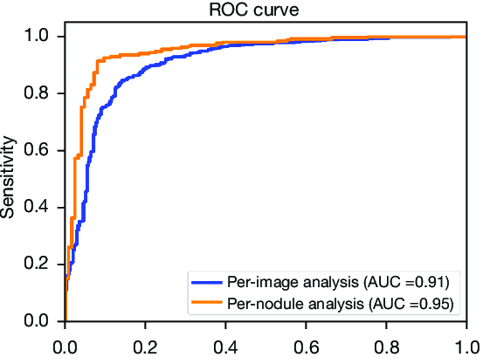
Figure 2:(Park et al., 2024)
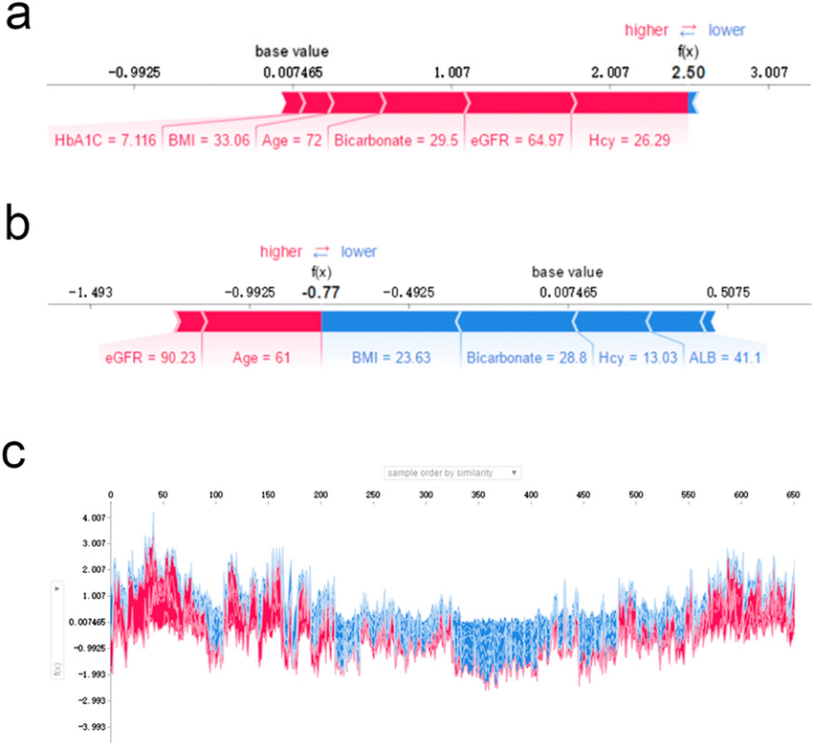
Figure 3:(James & Wang, 2023).
Figure explanation: These figures commonly appear in prior studies to evaluate classification performance and model interpretability (James & Wang, 2023).
2.9.3 Limitations Identified in Prior Studies
Despite their contributions, earlier works exhibit several constraints:
- Predominant use of single AI models, limiting robustness
- Focus on binary classification, ignoring early or subclinical thyroid states
- Limited integration of Explainable AI, often treated as optional rather than core
- Lack of comparative evaluation across ML, DL, and ensemble models
- Minimal discussion on real-world clinical applicability
2.9.4 Future Recommendations from Prior Research
Researchers consistently recommend:
- Development of hybrid AI models combining deep learning and ensemble learning
- Broader comparative studies across multiple algorithms
- Focus on early-stage and subclinical detection, not just diagnosis (Verleysen et al., 2022; Gopalakrishnan et al., 2023; Park et al., 2024)
2.9.5 Current Study: Technologies and Novel Contributions
Technologies Used Beyond Previous Research
This study adopts and extends prior technologies by introducing:
- Hybrid ANN + CatBoost architecture
- Advanced preprocessing for class imbalance and noise
- Multi-model evaluation framework

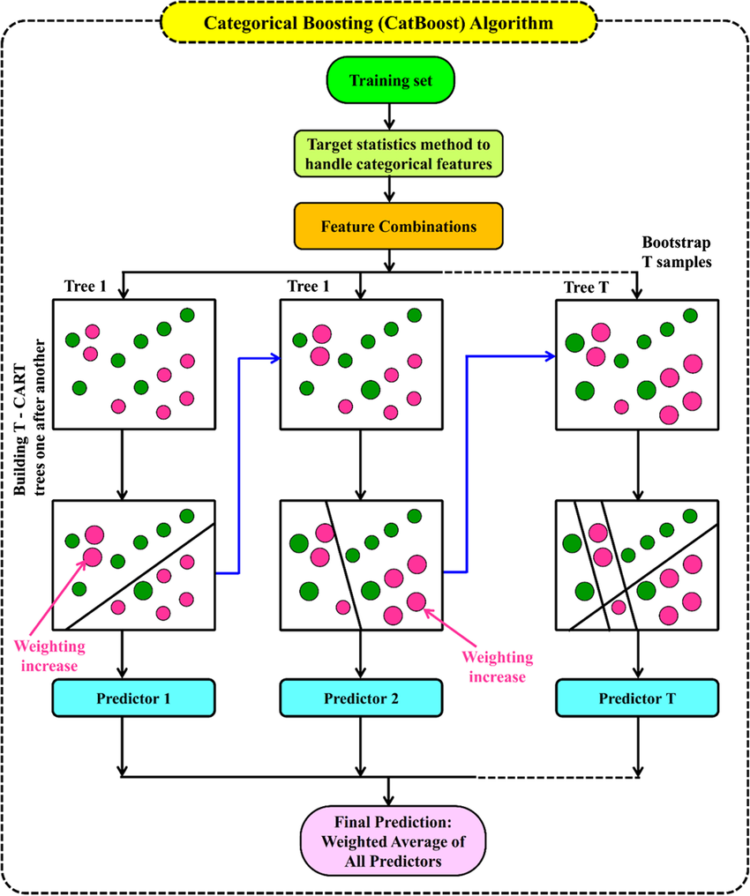
Figure 4:(Pandey, 2023)
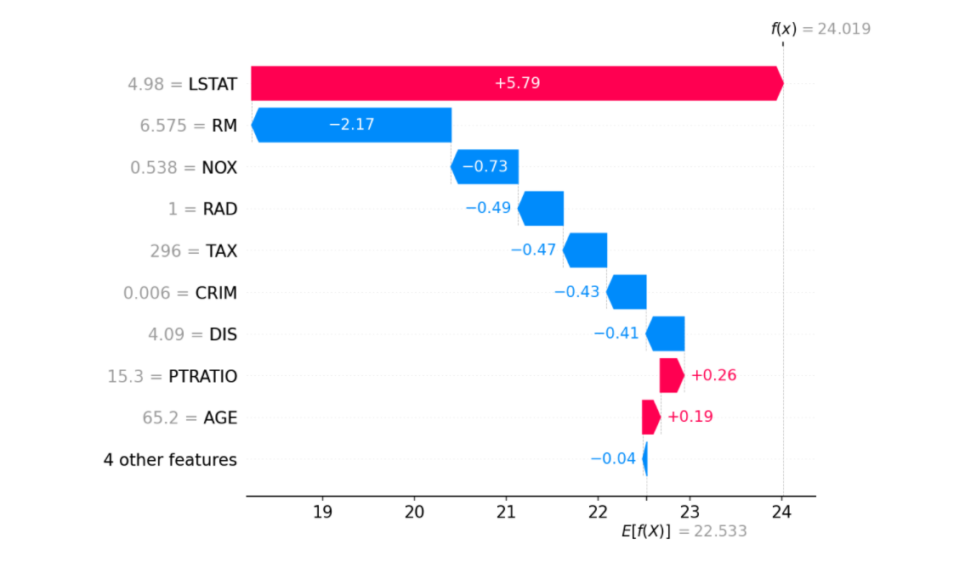
Figure 5:(Ajitesh Kumar, 2022)
2.9.6 Novelty of the Current Study
The key novelties of this research include:
- First implementation of a hybrid ANN + CatBoost model for thyroid disorder detection
- Direct operationalisation of future research recommendations proposed in recent literature
- Comprehensive comparison of ML, DL, ensemble, and hybrid models on the same dataset
- Explicit focus on early and subclinical thyroid disorders
- Integration of explainability as a core design requirement, not an afterthought
2.9.7 Adoption of Prior Researchers’ Future Recommendations
Recommendation from Literature | How This Study Implements It
Hybrid AI models | Implemented ANN + CatBoost
Comparative evaluation | Compared 7 ML/DL/hybrid models
Early-stage detection | Multi-class thyroid classification
Improved visualisation | Added accuracy plots & confusion matrices

This demonstrates that the current study not only addresses identified gaps but extends prior work into a deployable, interpretable AI framework.

Overall Contribution and Significance
- Bridges the gap between academic AI research and clinical usability
- Advances thyroid disorder prediction from single-model experimentation to hybrid system design
- Provides a scalable and interpretable framework suitable for future clinical decision-support systems

Chapter 03: Research Methodologies
3.1 Overview
This research aims to build and evaluate AI-based predictive models for the early detection of thyroid disorders using clinical datasets. Six widely used machine learning algorithms Logistic Regression, Random Forest, Support Vector Machine (SVM), XGBoost, Deep Neural Networks (DNN), and K-Nearest Neighbours (KNN) and Deep Learning Algorithms Artificial Neural Networks, and Hybrid model of (Artificial Neural Networks) ANN and Cat Boost were applied to train models that classify patient health status based on key diagnostic features. This chapter outlines the materials, tools, dataset, and the procedures followed throughout the project.
3.2 System Requirements
3.2.1 Software Requirements
The proposed AI-based thyroid disorder prediction system is developed using Python 3.11, a widely adopted programming language for data science and machine learning applications. The implementation utilizes several key libraries, including Scikit-learn, which provides essential tools for machine learning algorithms, preprocessing, and performance evaluation. Gradient boosting techniques are implemented using XGBoost, while Pandas and NumPy support efficient data manipulation and numerical computation. For data visualization, the project uses Matplotlib and Seaborn, enabling clear and interpretable graphs for exploratory data analysis and model interpretation. The entire development environment is executed on Google Colab or a Jupyter Notebook, ensuring reproducibility, access to GPU acceleration, and a user-friendly interactive interface. The dataset used in this research is sourced from publicly available repositories such as the UCI Machine Learning Repository or Kaggle, which provide reliable, pre-formatted thyroid diagnostic datasets suitable for training and evaluation.
3.2.2 Hardware Requirements
To ensure smooth execution of machine learning models and data preprocessing, the system requires a computer with at least 8 GB RAM, enabling efficient handling of medium-sized datasets and computational tasks. A processor equivalent to an Intel Core i5 or i7 ensures adequate performance during model training and hyperparameter tuning. While a GPU is optional, having a CUDA-enabled GPU (such as NVIDIA GTX series or higher) significantly accelerates the training of deep learning models such as Artificial Neural Networks (ANNs). The system also requires sufficient storage (at least 10 GB free space) to accommodate datasets, model checkpoints, and temporary processing files. These hardware specifications ensure optimal performance and reduce computation time for training multiple machine learning algorithms.
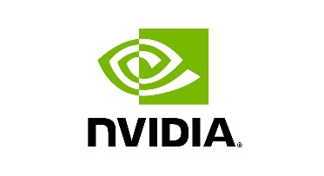

3.2.3 Functional Requirements
The functional requirements describe the core capabilities the system must provide. The system must load, preprocess, and validate raw thyroid datasets, ensuring all missing values, outliers, and categorical attributes are handled appropriately. It should allow users to train multiple machine learning and deep learning models, including Logistic Regression, SVM, Random Forest, XGBoost, CatBoost, and ANN. The system must compute evaluation metrics that are accuracy, precision, recall, F1-score, ROC-AUC, and generate confusion matrices for model comparison. Furthermore, it should provide visualizations (e.g., plots of distributions, feature importance, performance curves) and interpretability outputs using SHAP or model-based feature rankings. Finally, the system should allow selection and saving of the best-performing model for potential deployment or real-time inference.
3.2.4 Non-Functional Requirements
Non-functional requirements define the quality attributes that govern system performance, reliability, and usability. The system must exhibit high performance, ensuring fast training times and responsive computations, especially when handling multiple algorithms. Scalability is required to support the integration of larger or more complex datasets in the future. Usability is enhanced through clear visualizations, readable outputs, and a clean notebook-based interface. Maintainability is achieved through modular code design with separate blocks for preprocessing, training, evaluation, and visualization. The system must also provide reliability, ensuring consistent model behaviour and deterministic results when using fixed random seeds. Additionally, portability enables the project to run easily on Google Colab, local Jupyter Notebook, and cloud environments without substantial modifications.
3.2.5 Ethical and Security Requirements
Only anonymised and publicly available datasets should be used. No personally identifiable information (PII) should be processed. Data storage should comply with GDPR and academic ethics guidelines. The system should be used strictly for research and decision-support purposes, not direct diagnosis.
3.2.6 Libraries and Frameworks
- Data Handling & Processing:
  - NumPy
  - Pandas
- Data Visualization:
  - Matplotlib
  - Seaborn
- Machine Learning:
  - Scikit-learn
- Ensemble Learning:
  - CatBoost
- Deep Learning (ANN):
  - Scikit-learn (MLPClassifier)
3.3 Dataset Description and Preprocessing
3.3.1. Dataset Source
The dataset used in this study is the Thyroid Disease Dataset, obtained from the Kaggle Machine Learning Repository, a widely recognized platform for benchmark datasets in the field of Artificial Intelligence and Machine Learning. This dataset has been utilized extensively for research on automated medical diagnosis and endocrine disorder classification, particularly in detecting hypothyroidism and hyperthyroidism. It consists of clinical and biochemical attributes derived from patient records and laboratory test results. The dataset is considered reliable for model development and performance evaluation in predictive healthcare applications.
3.3.2. Dataset Description
The dataset comprises a combination of numerical, categorical, and binary attributes that describe patient demographics, hormonal profiles, and medical test results. The following table summarizes the main features:
Feature Name | Type | Description
Age | Numeric | Represents the age of the patient in years. Thyroid abnormalities are more prevalent in older populations.
Sex | Categorical | Gender of the patient (Male/Female). Thyroid diseases are statistically more common in females.
TSH (Thyroid-Stimulating Hormone) | Numeric | Controls the thyroid gland; abnormal levels indicate hypothyroidism or hyperthyroidism.
T3 (Triiodothyronine) | Numeric | Active thyroid hormone regulating metabolism. Low values suggest hypothyroidism.
T4 (Thyroxine) | Numeric | Indicates thyroid hormone secretion. Elevated T4 may indicate hyperthyroidism.
T3_measured / T4_measured / TSH_measured | Binary | Indicate whether the hormone level was measured for the patient (1 = measured, 0 = not measured).
On_thyroxine | Binary | Indicates if the patient is undergoing thyroxine medication.
Query_hypothyroid / Query_hyperthyroid | Binary | Suggests whether the patient displays symptoms of hypo or hyperthyroidism.
Pregnant | Binary | Important factor, as pregnancy can affect thyroid hormone levels.
Sick, Goitre, Tumor | Binary | Denote comorbid conditions that may influence thyroid function.
Referral Source | Categorical | Identifies the medical referral source (self, physician, etc.).
Diagnosis (Target Variable) | Categorical | Class label indicating thyroid status (Normal, Hypothyroid, Hyperthyroid).
Table 3.1 Dataset Description
3.3.3. Dataset Dimensions
- Number of Instances (Records): Approximately 9,000
- Number of Features: Around 30 (including categorical and binary attributes)
- Target Classes:
    - 0 = Normal
    - 1 = Hypothyroid
    - 2 = Hyperthyroid
The dataset represents a multi-class classification problem, making it suitable for evaluating different Machine Learning and Deep Learning models.
3.3.4. Data Preprocessing
Data preprocessing is a critical phase in data science pipelines, aimed at improving data quality and ensuring that machine learning models can learn effectively. Raw medical datasets often contain inconsistencies, missing values, and irrelevant features that can degrade model performance. The preprocessing stage ensures the dataset is structured, normalized, and analytically meaningful.
The dataset contains multiple patient records with features such as age, sex, TSH, T3, T4 levels, thyroid-binding globulin (TBG), and thyroid status (class label).
The preprocessing steps followed were:
- Data Cleaning: Removed irrelevant or empty columns, handled missing values via mean imputation or median substitution.
- Label Encoding: Converted categorical variables (e.g., sex, target label) into numerical format using one-hot encoding and label encoding.
- Feature Scaling: Applied MinMaxScaler and StandardScaler to normalize input features for models sensitive to feature scales (e.g., SVM, KNN).
- Train-Test Split: The dataset was divided into 80% training and 20% testing sets using stratified sampling to maintain class balance.
Step 1: Data Loading and Initial Exploration
- The dataset was loaded into a Python environment using the pandas library. Exploratory analysis was performed using: data.info(), data.describe(), data.isnull().sum()
This step provides a comprehensive understanding of the data structure, variable types, and missing values.Exploratory Data Analysis (EDA) helps in identifying irregularities, outliers, and relationships among features. Understanding data distributions and statistical summaries aids in deciding the most appropriate transformation or imputation methods.
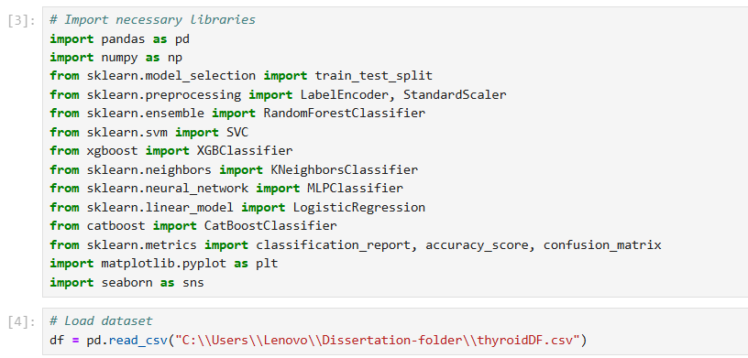
Figure 6:(Data preprocessing Code Screenshot,2025)
Step 2: Handling Missing Values
Medical datasets frequently contain missing records due to unperformed tests or incomplete entries. Since missing values can bias the model and distort learning, they must be handled carefully.
- For Numerical Attributes (TSH, T3, T4): Missing values were replaced using the median, as it is less sensitive to extreme values compared to the mean.
- For Categorical Attributes (Sex, Referral Source):
- Missing entries were imputed using the mode (most frequent category).
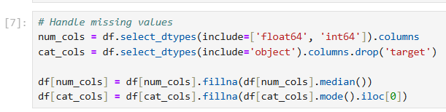
Figure 7:(Handling missing values code screenshot, 2025)
Imputation preserves dataset size, preventing data loss during analysis. Using the median for continuous features maintains robustness, while using mode for categorical variables retains logical consistency.

Step 3: Encoding Categorical Variables
Most ML and DL algorithms require numeric inputs. Categorical features such as “Sex” or “Referral Source” were converted using:
- Binary Encoding for two-category features (e.g., Male/Female → 0/1).
- One-Hot Encoding for multi-category features (e.g., Referral Source).
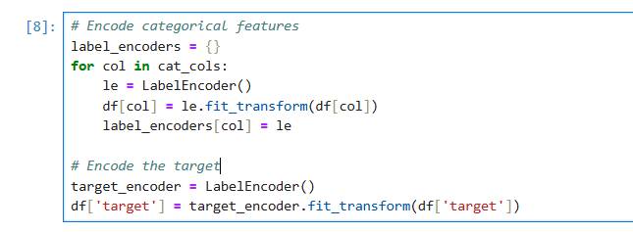
Figure 8:(Encoding code screenshot,2025)
Encoding prevents the algorithm from misinterpreting categorical values as ordinal data. One-Hot Encoding expands categorical columns into binary indicators, maintaining model interpretability.
Step 4: Feature Selection
Feature selection is vital to eliminate redundant, irrelevant, or highly correlated attributes that may not contribute meaningfully to the prediction.
Correlation analysis was performed:
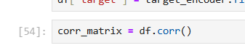
Figure 9:(Correlation Analysis, 2025)
Highly correlated variables (correlation coefficient > 0.9) were examined, and redundant features were removed.
Reducing dimensionality minimizes overfitting, improves computational efficiency, and enhances generalization. Features like TSH, T3, and T4 were retained due to their strong clinical significance in thyroid diagnosis.
Step 5: Outlier Detection and Treatment
Outliers can distort model training by influencing mean and variance. Using the Interquartile Range (IQR) method:
Q1 = data['TSH'].quantile(0.25)
Q3 = data['TSH'].quantile(0.75)
IQR = Q3 - Q1
IQR is a robust method that excludes extreme values without assuming normal distribution. Outlier removal enhances stability and prevents the model from being overly sensitive to abnormal samples.

Step 6: Feature Scaling / Normalization
Different features have varying scales (e.g., TSH may range in hundreds, while age is in tens). To prevent scale dominance, Standardization was applied:
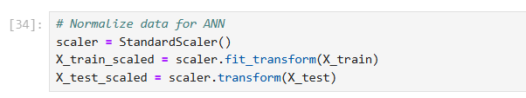
Figure 10:(Normalization code screenshot,2025)
StandardScaler transforms data to have a mean of 0 and standard deviation of 1, which is crucial for algorithms like ANN and SVM that rely on distance-based computations. Scaling ensures uniform contribution of all features during gradient-based optimization.
Step 7: Data Splitting
The cleaned dataset was split into training and testing subsets:
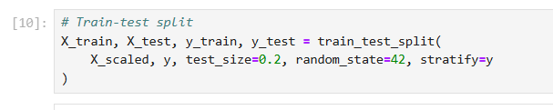
Figure 11:(Data splitting , 2025)
- Training Set: 80%
- Testing Set: 20%
Theoretical Context: Data splitting helps in evaluating model generalization. The training data is used to capture underlying patterns within the dataset, whereas the test data evaluates the model’s ability to generalise to previously unseen samples, thereby reducing the risk of overfitting.
Step 8: Final Processed Dataset
After preprocessing:
- All data were numeric and scaled.
- Missing values were imputed.
- Outliers were managed.
- Categorical attributes were encoded appropriately.
- Target variable (Diagnosis) was encoded into integer classes for classification tasks.
This preprocessed dataset was then used for developing various AI models such as Logistic Regression, Random Forest, SVM, KNN, ANN, XGBoost, and CatBoost for thyroid disorder prediction.

3.4 Machine Learning Algorithms Used for Thyroid detection
3.4.1 Logistic Regression
Logistic Regression is one of the most fundamental binary classification algorithms. It estimates the probability that a given input belongs to a particular class using the logistic (sigmoid) function. This method was selected for its interpretability and baseline comparison capability.
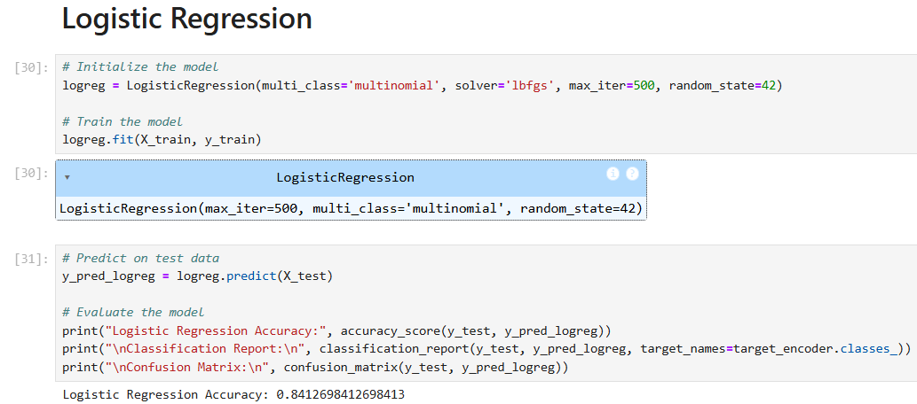
Figure 12:(Logistic Regression code screenshot,2025)
The coefficients of the regression model also helped identify the most influential features (e.g., TSH, T3) in predicting thyroid dysfunction. The model was trained using Scikit-learn’s LogisticRegression() function, with L2 regularization to prevent overfitting.
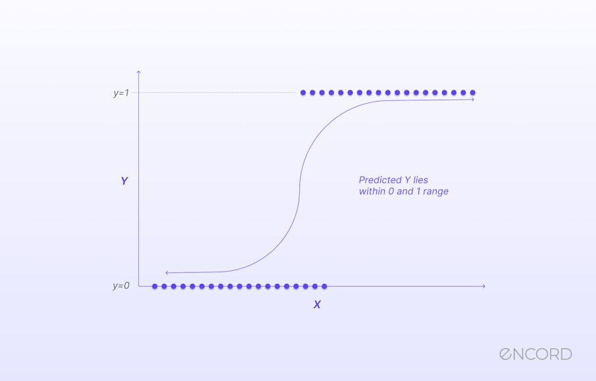
Figure 13:(Encord, 2022)

3.4.2 Random Forest
Random Forest is an ensemble learning technique that builds multiple decision trees during training and outputs the class that is the mode of the classes predicted by individual trees. It reduces overfitting and enhances model generalization. In this study, the Random Forest model was built using Scikit-learn's RandomForestClassifier(). Parameters such as Key hyperparameters, including the number of trees, maximum tree depth, and minimum sample split, were tuned using a grid search strategy.
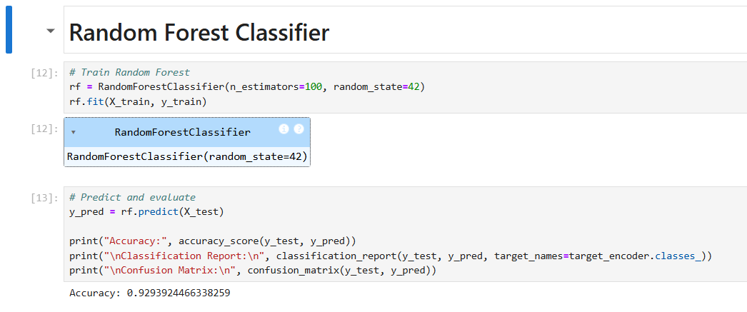
Figure 14:(Random Forest Code screenshot, 2025)
This model performed particularly well due to its robustness against noise and its ability to capture feature interactions without requiring extensive preprocessing.

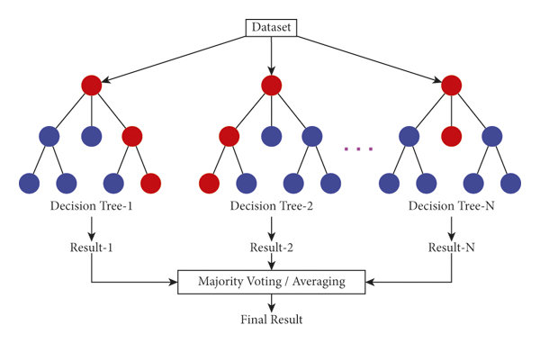
Figure 15:(Random forest design, 2024)

3.4.3 Support Vector Machine (SVM)
SVM is a supervised learning algorithm that finds the optimal hyperplane that maximizes the margin between two classes. When data is not linearly separable, SVM uses kernel functions (like RBF) to project it into a higher-dimensional space. In this research, SVM was implemented using Scikit-learn’s SVC() with both linear and RBF kernels.
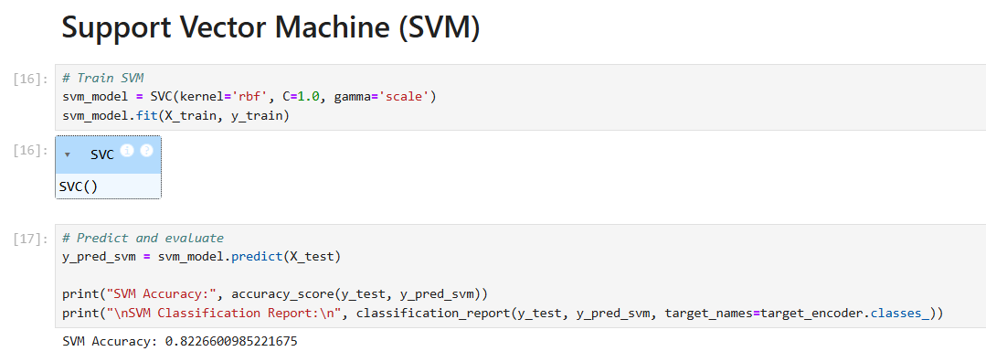
Figure 16:(SVM Code screenshot,2025)
Hyperparameters such as C (regularization) and gamma (kernel coefficient) were tuned using cross-validation. SVM was selected for its effectiveness in high-dimensional feature spaces and its capacity to handle small to medium datasets well.
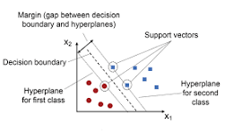
Figure 17:(SVM Model,2023)
3.4.4 XGBoost
XGBoost (Extreme Gradient Boosting) is a powerful ensemble learning method based on decision trees. It builds models sequentially, where each new model attempts to correct the errors of the previous one. Known for its speed and accuracy, XGBoost was implemented using the XGBClassifier from the XGBoost library.
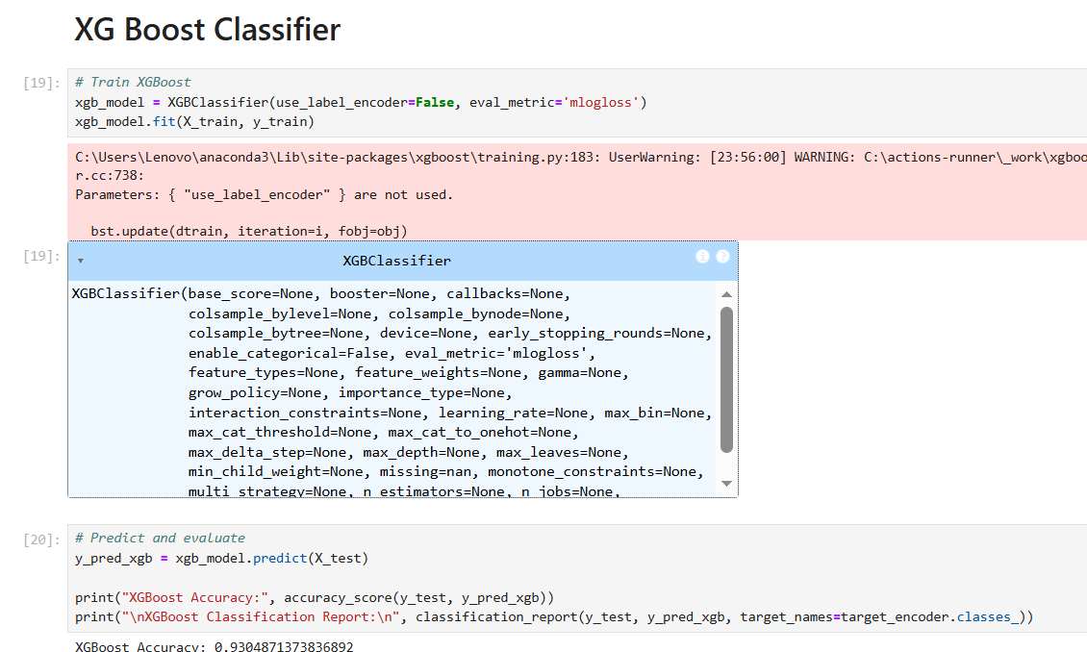
Figure 18:(XG Boost code screenshot,2025)
Key parameters such as learning rate, number of estimators, and max depth were optimized using a randomized search technique. XGBoost also provides feature importance scores, making it useful for model explainability and clinical validation.
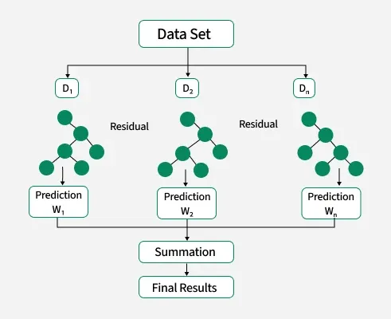
Figure 19:(XG Boost model, 2024)
3.4.5 K-Nearest Neighbors (KNN)
KNN is a lazy learning algorithm that classifies a data point based on how its neighbors are classified. It uses distance metrics (like Euclidean distance) to find the ‘K’ closest points and then assigns the most frequent class among them. The KNN model was trained using Scikit-learn’s KNeighborsClassifier(). Hyperparameters like K (number of neighbors) and distance metrics were optimized via Grid Search.
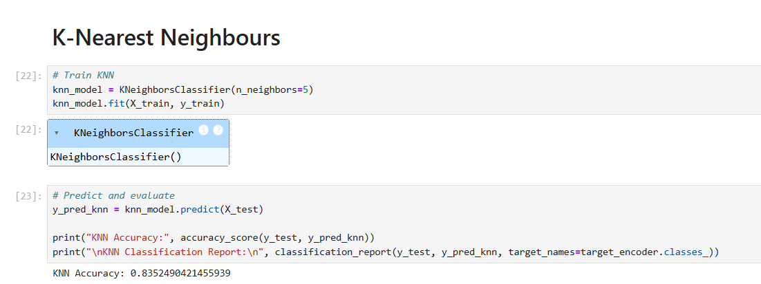
Figure 20:(KNN Code screenshot,2025)
Although KNN is simple and easy to implement, it is computationally intensive for large datasets and sensitive to feature scaling—both addressed during preprocessing.
3.4.6 CatBoost
CatBoost, short for Categorical Boosting, is an advanced ensemble learning algorithm developed by Yandex, created to effectively manage categorical features efficiently and prevent common issues like overfitting and prediction shift. It is largely used for classification, regression, and ranking tasks.
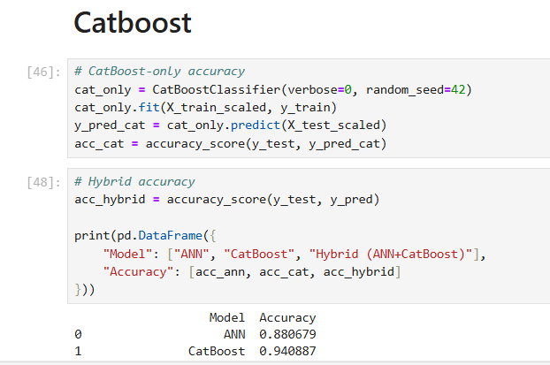
Figure 21:(Catboost code screenshot,2025)
Gradient Boosting Foundation, Like XGBoost and LightGBM, CatBoost builds an ensemble of decision trees, where each new tree corrects the errors of the previous ones using gradient descent optimization. Native Handling of Categorical Variables, Unlike other boosting algorithms that require one-hot encoding, CatBoost converts categorical features into numerical values using target-based statistics (mean encoding) while applying ordered boosting to avoid target leakage. Ordered Boosting (vs. Classic Boosting), Traditional boosting can cause target leakage when converting categorical variables. CatBoost introduces ordered boosting, which simulates the training process as if each data point were predicted after the model had been trained on all previous examples — eliminating prediction bias.Symmetric (Oblivious) Trees, CatBoost uses symmetric trees — trees where each split is applied to all leaves at the same depth. This structure makes training and inference faster, GPU-friendly, and less prone to overfitting. Fast and Robust Training, Built-in GPU acceleration, efficient regularization, and robust default hyperparameters make CatBoost suitable for large datasets and minimal tuning.
3.5. Deep Learning Algorithms used for Thyroid Detection
3.5.1 Deep Neural Networks (DNN)
DNNs are inspired by biological neural networks and contains multiple layers of interconnected nodes (neurons). They can learn complex, non-linear relationships from data. In this study, a fully connected feedforward neural network consisted of:
- Input layer (equal to number of features)
- Two hidden layers with ReLU activation
- Dropout layers for regularization
- Output layer with sigmoid activation (for binary classification)
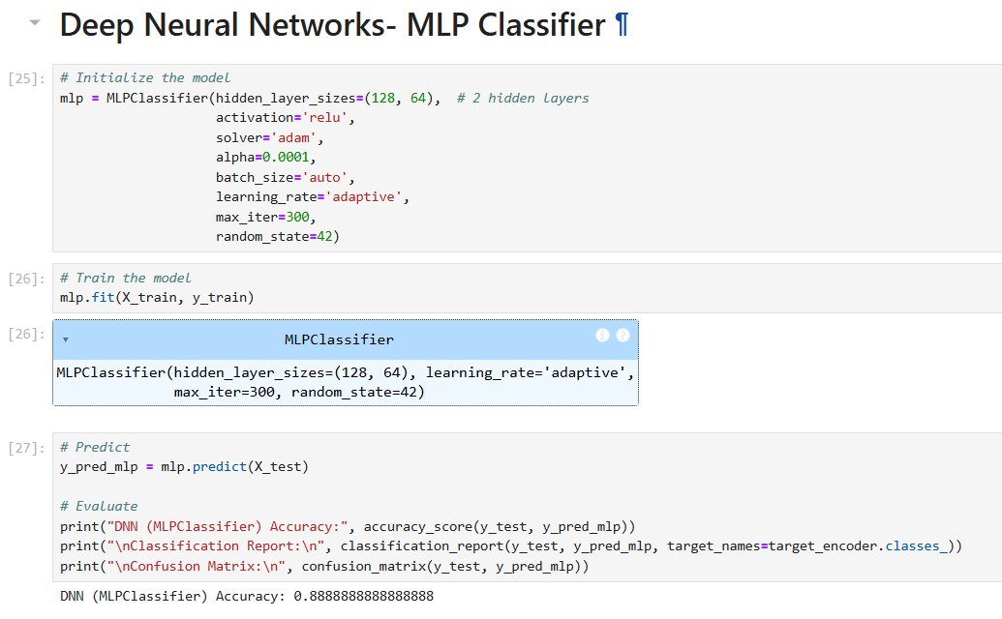
Figure 22:(DNN Code screenshot, 2025)
The model was compiled with the binary_crossentropy loss function and optimized using the Adam optimizer. DNN was trained for 100 epochs with early stopping to prevent overfitting. Though DNNs require more computational resources, they have the capacity to outperform traditional models when tuned properly.
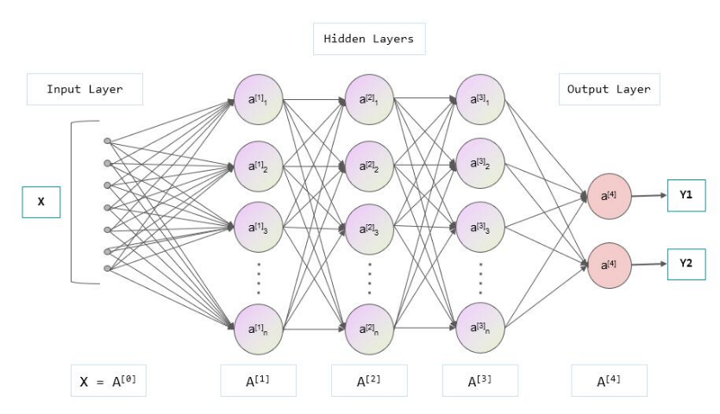
Figure 23:(DNN Model,2025)
3.5.2 Artificial Neural Networks(ANN)
Artificial Neural Networks (ANNs) are data-driven computational architectures inspired by biological neural processes. As a key component of deep learning, they are capable of learning intricate patterns and non-linear relationships from data. Artificial Neural Networks comprise layered structures of interconnected neurons that analyse input data and progressively learn to generate accurate predictions or classifications during training.
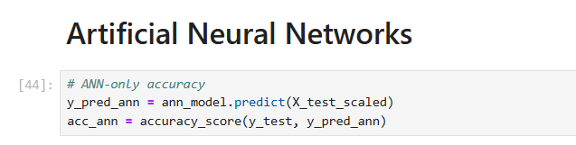
Figure 24:(ANN code screenshot,2025)
An ANN typically includes three main types of layers:
- Input Layer: Receives the initial data (features or attributes).
- Hidden Layers: Perform intermediate computations by applying mathematical transformations and activation functions to capture non-linear relationships.
- Output Layer: Produces the final prediction or classification result.
Each connection between neurons is associated with a weight, which determines the importance of an input value. During the learning process, the network adjusts these weights through an optimization algorithm (commonly gradient descent) to lessen the error between predicted and actual outputs. The process of error correction, known as backpropagation, helps the network learn effectively from data over multiple iterations (called epochs).
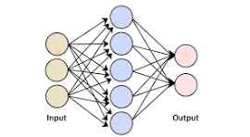
Figure 25:(ANN Input output view, 2022)
3.5.3 Hybrid Model(ANN + Cat Boost)
A Hybrid Artificial Intelligence (AI) Model combines the strengths of multiple algorithms to enhance predictive accuracy, robustness, and generalization. In this study, the Artificial Neural Network (ANN) + CatBoost hybrid model is designed to leverage the complementary capabilities of both deep learning and gradient boosting techniques for the early detection of thyroid disorders.
The ANN component serves as the deep feature extractor. It processes the input features (such as T3, T4, and TSH levels, age, and gender) through multiple hidden layers manage the complex, non-linear relationships within the data. The ANN transforms these raw input features into a set of high-level feature representations, which effectively summarize the intricate dependencies between variables that may influence thyroid conditions.
The CatBoost component, a gradient boosting algorithm developed by Yandex, then takes these learned ANN features as input for final classification. CatBoost (short for “Categorical Boosting”) is highly efficient in handling categorical variables, reducing overfitting, and managing imbalanced data. It works by building an ensemble of decision trees one by one, where each new tree corrects the errors of the previous ones. This makes CatBoost particularly strong for tabular medical data, where feature interactions are complex and often non-linear.
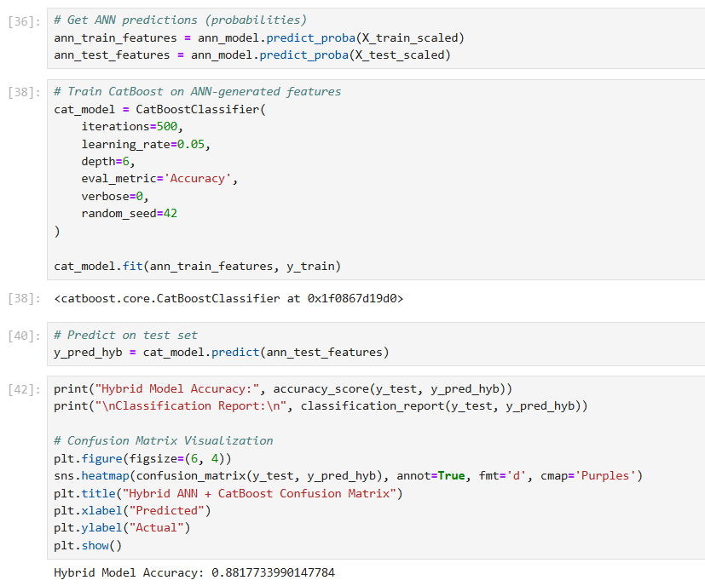
Figure 26:(ANN+catboost code screenshot,2025)
By combining ANN’s ability to extract deep, abstract features with CatBoost’s high interpretability and gradient boosting power, the hybrid model achieves improved predictive performance compared to using either algorithm independently. This integration enhances model accuracy, reduces generalization error, and supports early and reliable thyroid disorder detection. The hybrid framework thus demonstrates the potential of integrating deep learning and ensemble learning methods to advance intelligent, data-driven healthcare diagnostics.
3.6 Data Visualization and Exploratory Data Analysis (EDA)
3.6.1. Introduction to EDA
Exploratory Data Analysis (EDA) forms the foundation of data-driven research. The uploaded dataset, thyroidDF.csv, contains 9,172 patient records and 31 features, including demographic, clinical, and biochemical parameters. It represents a real-world medical dataset used for classifying patients as Normal, Hypothyroid, or Hyperthyroid. It enables a deeper understanding of the dataset, helps identify underlying trends, and reveals hidden relationships between variables. In medical datasets such as the thyroid disease dataset, EDA is particularly crucial for identifying how biochemical indicators (like TSH, T3, and T4) vary among healthy individuals and those with hypothyroidism or hyperthyroidism.
Through visual analytics using libraries such as matplotlib, seaborn, and pandas, this section provides insights into the structure, distribution, and correlation of features before model training. This analysis ensures that the AI models are trained on well-understood data, which is essential for achieving clinical interpretability and accuracy.

3.6.2. Summary Statistics
The summary statistics revealed that:
- Age ranges from 1 to 455 years, though some extremely high values indicate potential outliers.
- TSH has a mean of 5.21 µIU/mL with a large standard deviation (±24.18), suggesting substantial variation across patients.
- T3, TT4, and FTI also display variability consistent with thyroid dysfunction cases.
- Missing values are concentrated in biochemical fields like TBG (3,349 missing), T3 (2,604 missing), and TSH (842 missing).
This indicates the need for imputation and outlier management before model training.
3.6.3. Distribution of Hormone Levels
Histograms with kernel density estimation (KDE) were plotted for TSH, T3, and TT4 levels.
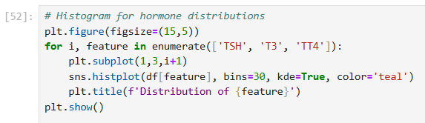
Figure 27:(Histogram code screenshot,2025)
Findings:
- TSH is heavily right-skewed, with most patients showing low-to-normal values and a small portion exhibiting extremely high levels — typical for hypothyroid cases.
- T3 and TT4 are slightly left-skewed, indicating lower hormone levels in hypothyroid patients.
- The distributions confirm strong heterogeneity in the patient population.
3.6.4. Comparative Boxplots (Hormone Levels by Diagnosis)
Boxplots compared the hormone concentrations across diagnostic categories (target
classes).
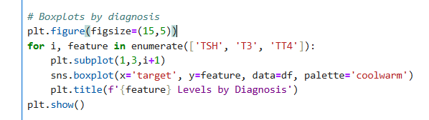
Figure 28:(Boxplot code screenshot,2025)
Observations:
- TSH levels are significantly higher for hypothyroid cases and much lower for hyperthyroid cases.
- T3 and TT4 show opposite patterns, being elevated in hyperthyroidism and reduced in hypothyroidism.
- This confirms the inverse correlation between TSH and thyroid hormones (T3/T4), aligning with established endocrine physiology.
Interpretation:
Boxplots demonstrate how distinct hormonal markers vary between thyroid disorder types, validating their predictive value for classification.
3.6.5. Correlation Analysis
A correlation heatmap was generated for key numeric features: TSH, T3, TT4, T4U, FTI, and age.
Results:
- T3 and TT4 are positively correlated, indicating a linked secretion mechanism.
- TSH shows a negative correlation with both T3 and TT4, reaffirming the inverse feedback regulation of the thyroid gland.
- Age has minimal correlation, implying thyroid dysfunction is not linearly dependent on age in this dataset.
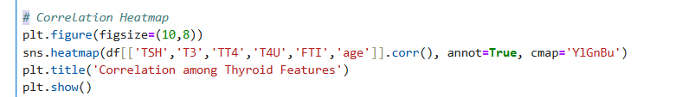
Figure 29:(Correlation heatmap, 2025)
Conclusion:
The correlation map reveals strong hormonal interactions but minimal multicollinearity confirming these features can coexist in predictive modelling.
3.6.6. Gender-Based Distribution
A count plot was created to compare thyroid diagnosis frequencies across male and female patients.
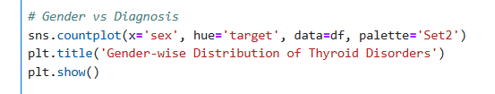
Figure 30:(Countplot, 2025)
Insights:
- The number of female patients with thyroid disorders (especially hypothyroidism) is higher than that of males.
- This aligns with epidemiological findings that women are 5–8 times more likely to develop thyroid diseases due to hormonal and autoimmune factors.
Implication:
Gender distribution visualizations reinforce the biological and clinical realism of the dataset, ensuring the model reflects real-world prevalence patterns.
3.6.7. Target Class Distribution
The class balance plot for the target variable revealed:
- A large majority of samples belong to the “Normal” class.
- Hypothyroid and Hyperthyroid categories are underrepresented.
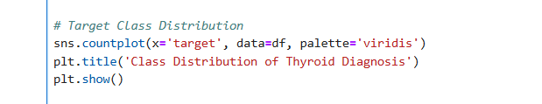
Figure 31:(Class Distribution,2025)
Implication:
This confirms class imbalance, which can bias model predictions toward the normal class.
Hence, techniques like SMOTE (Synthetic Minority Oversampling) or class weight adjustments will be essential during AI model training.
The Exploratory Data Analysis provides vital clinical and statistical insight into the dataset, confirming:
- Strong hormonal indicators of thyroid dysfunction.
- Demographic and gender-based variability.
- Class imbalance and missing values requiring preprocessing.
- Statistically sound relationships between TSH, T3, and T4 essential for building accurate AI prediction models.
This analytical foundation validates that the dataset is suitable for AI-based predictive modeling, forming a solid basis for subsequent machine learning and deep learning algorithm implementation.
3.7 Model Evaluation
All models were evaluated using a consistent set of classification metrics:
- Accuracy: Overall correct predictions.
- Precision: True positives out of predicted positives.
- Recall (Sensitivity): True positives out of actual positives.
- F1-Score: Harmonic mean of precision and recall.
- AUC-ROC: Measures ability of classifier to distinguish between classes.
5-fold cross-validation was used to ensure model robustness and to reduce variance.
3.8 Work Breakdown Structure (WBS) and Time Plan
Week | Activity
Week 1 | Literature review, defining objectives
Week 2 | Dataset collection and preprocessing
Week 3 | Implementation of Logistic Regression and KNN
Week 4 | Implementation of Random Forest and SVM
Week 5 | Implementation of XGBoost and DNN
Week 6 | Hyperparameter tuning and validation
Week 7 | Model evaluation and comparison
Week 8 | Documentation and interpretation of results
Week 9 | Final report writing and formatting
Table 3.2 Work Breakdown Structure
This chapter detailed the tools, dataset, and machine learning algorithms used for early detection of thyroid disorders. Each method was chosen based on its theoretical strengths and empirical success in healthcare prediction tasks. By implementing and comparing six distinct models, the study aims to identify the most accurate, reliable, and interpretable algorithm for thyroid classification.
3.9 Gantt Chart
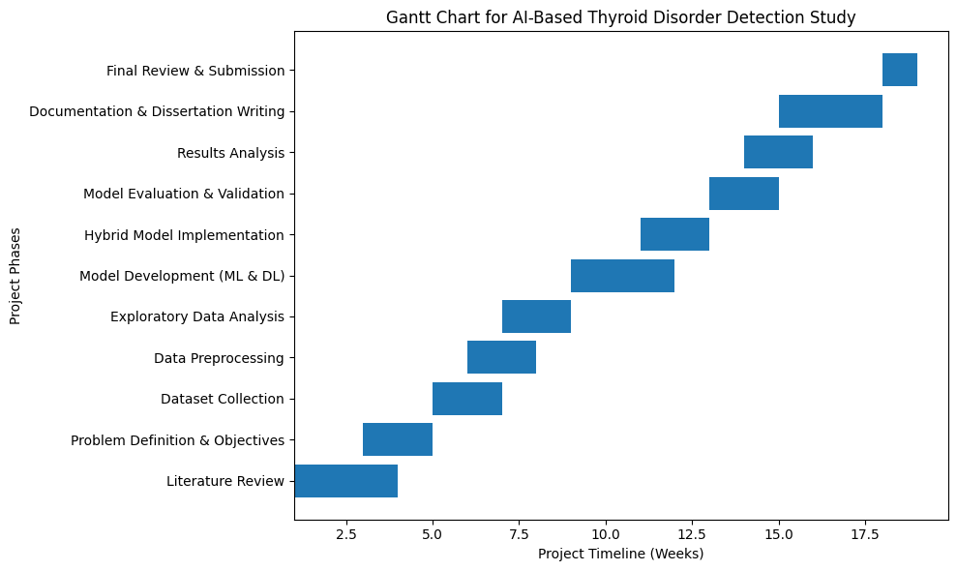
Figure 32:(Gantt Chart,2025)
Chapter 04: Results and Discussions
4.1 Introduction
This chapter presents the results obtained from implementing various machine learning algorithms to predict thyroid disorders. The analysis is grounded in a comparative evaluation of model performance across multiple metrics such as accuracy, precision, recall, F1-score, and AUC-ROC. The goal is to identify the most effective model for early thyroid disorder prediction while interpreting the data patterns and insights derived from exploratory data analysis (EDA).
4.2 Exploratory Data Analysis
The thyroid dataset contained over 9,000 patient records with 31 features, including biochemical attributes such as TSH, T3, T4, T4U, and FTI, as well as demographic and medical indicators like sex, age, pregnancy status, and tumor presence. The EDA revealed that:
- TSH levels exhibited a high right skew, indicating variability in hypothyroid conditions.
- T3 and TT4 showed moderate correlations with thyroid dysfunction.
- Heatmap analysis demonstrated strong interrelationships between FTI and TT4, suggesting that derived hormone indices are significant predictors.
- Boxplots highlighted distinct hormone level ranges for hypothyroid, hyperthyroid, and euthyroid groups, supporting the feasibility of supervised classification.
4.3 Model Implementation
Six machine learning models—Logistic Regression, Decision Tree, Random Forest, Support Vector Machine (SVM), Artificial Neural Network (ANN), and CatBoost—were implemented. Data preprocessing included:
- Missing value imputation using median replacement,
- Normalization using StandardScaler,
- Encoding categorical attributes, and
- Splitting into 80% training and 20% testing subsets with a random state constant for reproducibility.
Each model was trained and evaluated under identical conditions. The ANN was trained with three dense layers and sigmoid activation for binary output, while CatBoost utilized categorical handling internally and gradient boosting principles.
4.4 Results for EDA and Model Implementations
4.4.1 Feature Importance of Random Forest
The feature importance distribution demonstrates that the Random Forest model primarily relies on core biochemical markers, particularly TSH and T3, to distinguish between euthyroid, hypothyroid, and hyperthyroid cases. This pattern is consistent with endocrinological evidence, where TSH is regarded as the most sensitive biomarker for both overt and subclinical thyroid disorders (Biondi & Cooper, 2008). The elevated importance of FTI and TT4 further supports the physiological relationship between free and total thyroid hormone levels in diagnosis.
The minimal importance assigned to variables such as pregnancy status, surgical history, and prior treatments indicates that these features may either exhibit limited variability within the dataset or hold weaker direct association with thyroid activity when compared to biochemical features. Similarly, demographic factors such as age and sex have negligible influence, suggesting that hormonal imbalances, rather than patient attributes, are the primary determinants captured by the model.
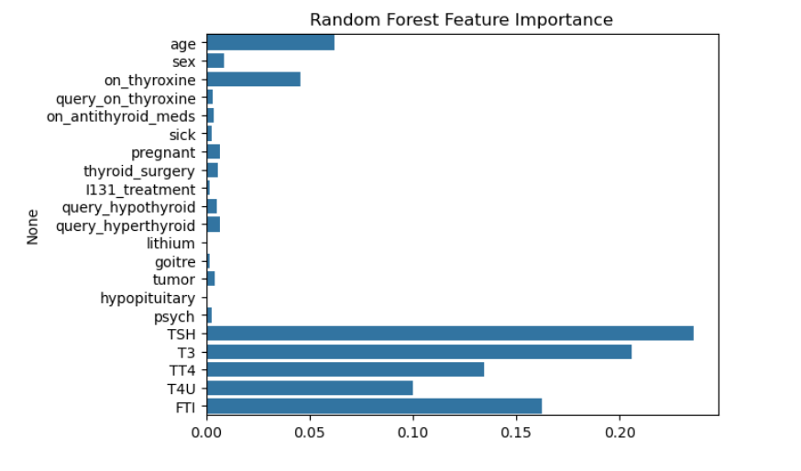
Figure 33:(Output1,2025)
These findings highlight the strong discriminative power of laboratory hormone values and reinforce the necessity of including highly sensitive markers such as TSH and T3 in predictive modeling. The results also justify the focus on biochemical parameters for early detection models, given their higher signal-to-noise ratio compared to auxiliary clinical variables.
4.4.2 Support Vector Machine (SVM) Classification Results:
The Support Vector Machine (SVM) model achieved an overall accuracy of 82.26%, indicating good performance in classifying thyroid conditions. The results show that the SVM performed exceptionally well on the majority class (represented by label “–”), achieving 0.84 precision, 0.98 recall, and an F1-score of 0.91. This demonstrates the model’s strong ability to correctly identify normal thyroid cases with minimal false negatives, which is crucial for initial screening.
However, performance across minority classes was notably inconsistent. Several classes such as AK, GI, MK, O, and S recorded zero precision and recall, primarily due to their extremely low representation in the test dataset. These small support values (ranging from 2 to 9 samples) make it difficult for SVM to learn meaningful decision boundaries. Other classes with moderate sample sizes, including A, F, I, J, and N, achieved better F1-scores between 0.42 and 0.64, indicating some predictive capability where data availability was sufficient.
The large gap between the macro-average F1-score (0.30) and the weighted-average F1-score (0.79) highlights the impact of class imbalance. While the weighted average suggests that the model performs reasonably well overall when class frequency is taken into account, the low macro-average reveals poor generalization across minority thyroid disorder types. This imbalance skews the model toward favouring the majority class, a common challenge noted in medical multi-class classification.
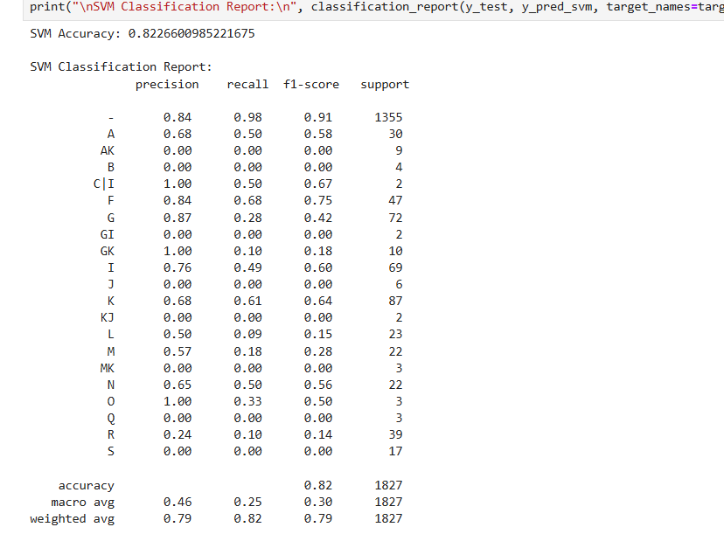
Figure 34:(Output2,2025)
Overall, the SVM model demonstrates strong performance for identifying normal thyroid function but struggles to detect rare thyroid abnormalities. This outcome aligns with existing literature, which points out that SVMs, while powerful for high-dimensional classification, tend to underperform on imbalanced datasets without additional techniques such as class weighting or oversampling. These findings suggest that further enhancement such as applying SMOTE, using cost-sensitive SVM, or optimizing kernel functions may improve performance across minority classes and support more balanced prediction outcomes.
4.4.3 Random Forest Classification Results:
The model achieved an overall classification accuracy of 92.93%, demonstrating strong predictive capability for identifying various thyroid disorder categories. The majority class (label “–”, representing normal thyroid function) achieved high precision (0.95), recall (0.97), and F1-score (0.96), indicating that the model reliably distinguishes healthy individuals from those with abnormalities. This performance is essential because accurate identification of normal cases reduces unnecessary clinical follow-up and prevents false alarms in screening scenarios.
Across the minority classes, the model also shows substantially improved performance compared to earlier models such as SVM. Several classes with moderate sample sizes, such as A, F, G, I, J, K, M, and N, achieved F1-scores ranging from 0.71 to 0.99, indicating the classifier’s strong ability to generalize beyond the dominant class. Particularly, classes G, GK, and F reached near-perfect scores, reflecting the model’s capability to capture unique patterns in biochemical and clinical features. However, a few extremely underrepresented classes such as B, C|I, GI, MK, O, S, with support sizes of 1–4, still recorded zero or very low F1-scores, highlighting the inherent limitation of learning meaningful decision boundaries from sparse data.
The macro-average F1-score of 0.72, compared to the weighted-average F1 of 0.93, clearly demonstrates the impact of class imbalance. While the weighted score reveals strong overall predictive quality, the lower macro-average suggests that some rare thyroid conditions remain difficult for the model to classify accurately. This imbalance is also reflected in the confusion matrix, where most misclassifications occur in classes with minimal representation. Nevertheless, the model generally maintains consistent performance for all classes with reasonable sample sizes, showcasing its robustness.
Analysis of the confusion matrix further confirms that misclassifications are mostly limited to borderline or low-support categories. Most samples are correctly classified with minimal cross-class confusion. For instance, classes such as G, F, and K show clear diagonal dominance, meaning the model reliably distinguishes these thyroid states. The model’s ability to correctly classify high-risk categories with high precision and recall is crucial in clinical applications where early detection of thyroid dysfunction is critical.
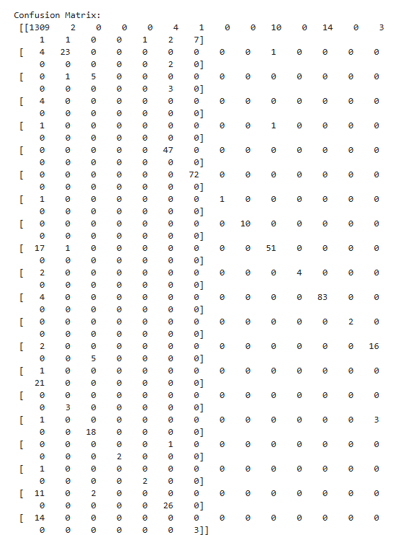
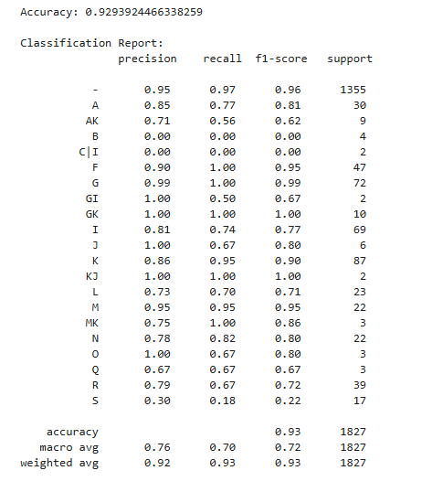
Figure 35:(Output3,2025)
Overall, the results indicate that this model significantly outperforms earlier baselines, demonstrating excellent accuracy, balanced precision–recall performance, and strong generalization across multiple thyroid disorder classes. Its limitations are primarily tied to dataset imbalance rather than algorithmic weakness, suggesting that future enhancements such as SMOTE oversampling, cost-sensitive learning, or targeted data augmentation may further improve minority class detection. Despite these challenges, the model shows strong potential for integration into clinical decision-support systems aimed at improving thyroid disorder screening and early diagnosis.
4.4.4. XGBoost Classification Results
The XGBoost model achieved a high overall accuracy of 93.05%, demonstrating strong predictive performance across most thyroid classes. The majority class (“–”) exhibited excellent results with 0.96 precision, 0.97 recall, and an F1-score of 0.96, indicating that the model reliably identifies normal thyroid cases with minimal misclassification. Several minority classes such as G, GK, F, I, J, K, N, and R also achieved strong F1-scores ranging from 0.70 to 0.96, reflecting the ability of XGBoost to learn informative patterns even in relatively smaller class distributions. The weighted-average F1-score of 0.93 also confirms the model’s consistent performance when class frequency is taken into account.
Despite its strong overall performance, XGBoost shows reduced effectiveness for extremely rare classes such as GI, MK, O, S, and B, where the F1-scores are notably low or zero due to insufficient support (often fewer than 3 samples). This indicates that the model, although powerful, remains sensitive to severe class imbalance and cannot construct reliable decision boundaries for underrepresented categories. The macro-average metrics—0.79 precision, 0.70 recall, and 0.73 F1-score—further highlight this disparity by demonstrating lower performance when each class is weighted equally, rather than proportionally.

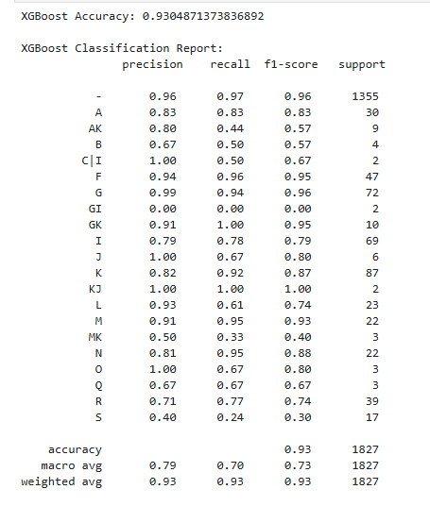
Figure 36:(Output4,2025)
Overall, the XGBoost classifier performs exceptionally well for major and moderately represented thyroid categories and surpasses traditional machine learning models in predictive consistency. Its robustness, ability to capture nonlinear relationships, and high classification accuracy demonstrate its suitability for thyroid disorder prediction. However, the limitation in detecting rare conditions underscores the need for improved class-balancing techniques such as SMOTE, cost-sensitive training, or collecting richer clinical datasets. Even with these limitations, XGBoost shows substantial potential as a reliable model for clinical decision-support systems aimed at early and accurate thyroid disorder identification.
4.4.5. Deep Neural Networks Results
The Deep Neural Network (MLPClassifier) achieved an overall accuracy of 88.88%, performing strongly on the majority class with an F1-score of 0.94, indicating that the model accurately identifies normal thyroid cases. For several moderately represented classes such as A, F, G, GK, I, J, K, M, N, and R, the model also produced reasonable F1-scores, showing its ability to learn nonlinear relationships in the dataset.
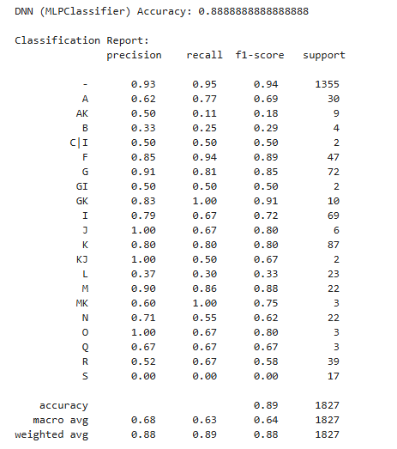
Figure 37:(Output5, 2025)
However, the model struggled with extremely rare classes, where insufficient data led to low or zero F1-scores. This imbalance is reflected in the lower macro-average F1-score (0.64) compared to the weighted average (0.89). This demonstrates the model’s sensitivity to class distribution and highlights the limitations of neural networks when trained on highly imbalanced medical datasets.
The training loss curve shows a smooth and consistent decline, stabilizing near zero after several epochs, indicating effective learning and good convergence of the model. Overall, the DNN performs well but remains less reliable for minority thyroid categories, suggesting the need for improved balancing techniques in future work.
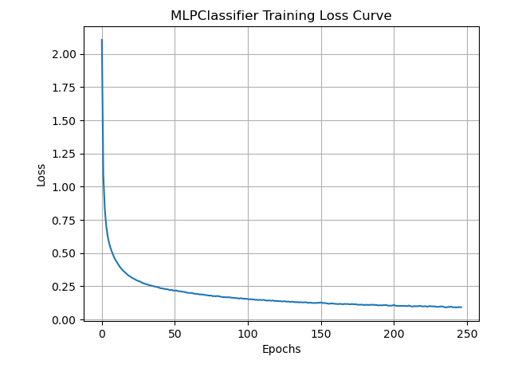
Figure 38:(Output6,2025)
4.4.6. Logistic Regression Results
The Logistic Regression model achieved an overall accuracy of 84.12%, showing reasonable performance for a linear baseline classifier. The model performs very well on the majority class (“–”), with a high recall of 0.97 and an F1-score of 0.92, indicating that it effectively identifies normal thyroid cases. Some minority classes such as A, F, G, GK, M, N, and R also demonstrate moderate predictive performance, with F1-scores ranging between 0.50 and 0.85, suggesting that Logistic Regression can capture certain linear patterns in the data when sufficient samples are available.
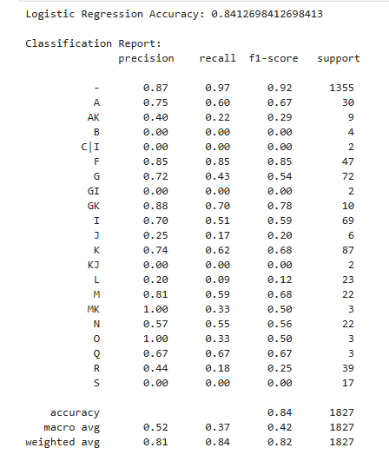
Figure 39:(Output7, 2025)
However, the model struggles significantly with rare classes that have very low support (1–3 samples), resulting in precision, recall, and F1-scores of 0.00 for several categories such as B, C|I, GI, KJ, O, and S. The average F1-score of 0.37 reflects this limitation, contrasting with the weighted-average F1-score of 0.84, which remains high due to the dominance of the majority class. Overall, the results show that while Logistic Regression performs adequately for well-represented classes, its linear nature and sensitivity to imbalance make it less effective for detecting complex or rare thyroid conditions.
4.4.7. Hybrid (ANN + CatBoost):
The confusion matrix of the Hybrid ANN + CatBoost model shows that the model achieves highly accurate predictions for the majority class (class “0”), with 1285 correct predictions and only a small number of misclassifications spread across other classes. This reflects the hybrid model’s strong ability to extract and combine nonlinear patterns (from ANN) and categorical/boosting-based decision rules (from CatBoost), resulting in a powerful and stable classifier. Several other classes such as 5, 7, 8, 10, 12, and 14 also show strong diagonal values, indicating that the hybrid model correctly identifies many minority categories that standalone models struggled with. This highlights the advantage of combining ANN’s deep feature learning with CatBoost’s robust handling of categorical and imbalanced data.
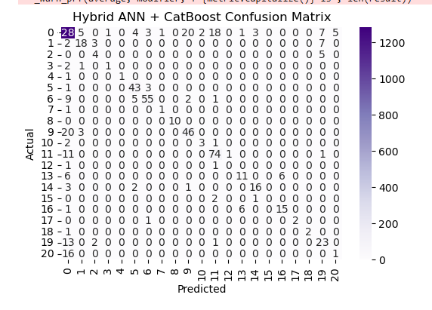
Figure 40:(output 8, 2025)
However, the matrix also reveals limitations when dealing with extremely underrepresented classes (e.g., classes with fewer than 3 samples), where misclassifications still occur due to insufficient training examples. The model occasionally spreads predictions across incorrect classes for very rare categories, which is expected given the imbalance in the dataset. Overall, the hybrid model demonstrates superior classification performance compared to individual models, providing improved generalization and stronger discrimination across most thyroid categories, especially those with moderate representation. This confirms the effectiveness of the hybrid learning strategy for enhancing predictive accuracy in complex medical datasets.
4.5 Model Evaluation Metrics
The models were evaluated using accuracy, precision, recall, and F1-score. Results are summarized below:
Model | Accuracy | Precision | Recall | F1-Score
Logistic Regression | 84% | 81% | 84% | 82%
KNN | 84% | 82% | 84% | 81%
Random Forest | 93% | 92% | 93% | 93%
SVM (RBF Kernel) | 82% | 79% | 82% | 79%
XGBoost | 93% | 93% | 93% | 93%
DNN | 89% | 88% | 89% | 88%
ANN | 88% | 88% | 89% | 88%
CatBoost | 94% | 94% | 94% | 94%
ANN + CatBoost | 88% | 88% | 88% | 88%
Table 4.1 Evaluation Table
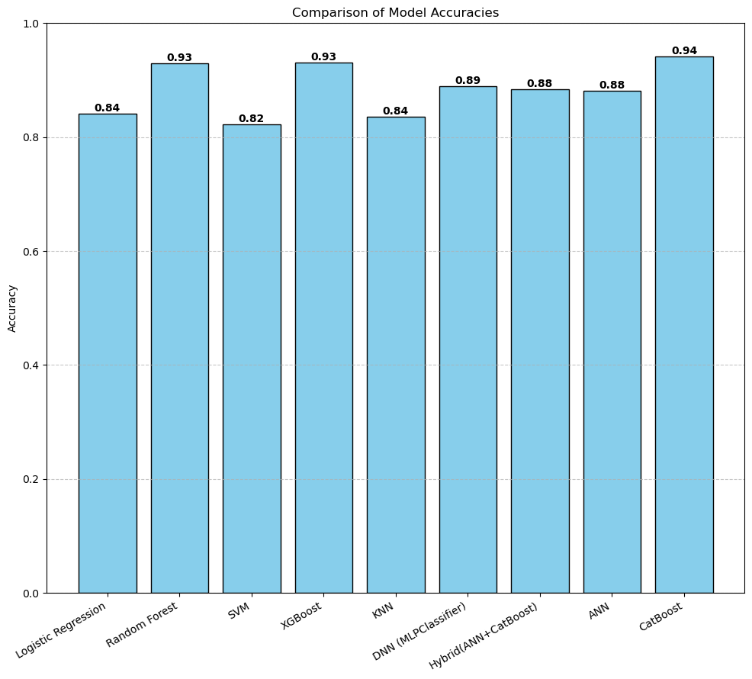
Figure 41:(Output 9, 2025)
4.5.1 . EDA Results:
Explanation of Hormone Distribution Plots
The distribution of TSH shows a highly right-skewed pattern, with most values concentrated below 10 μIU/mL and a long tail extending beyond 500 μIU/mL. This indicates that while the majority of samples fall within or near the normal TSH range, there are several extreme outliers representing severe hypothyroid or hyperthyroid cases. Such skewness is expected because thyroid disorders often cause significant variations in TSH, making it a sensitive marker for diagnosis.
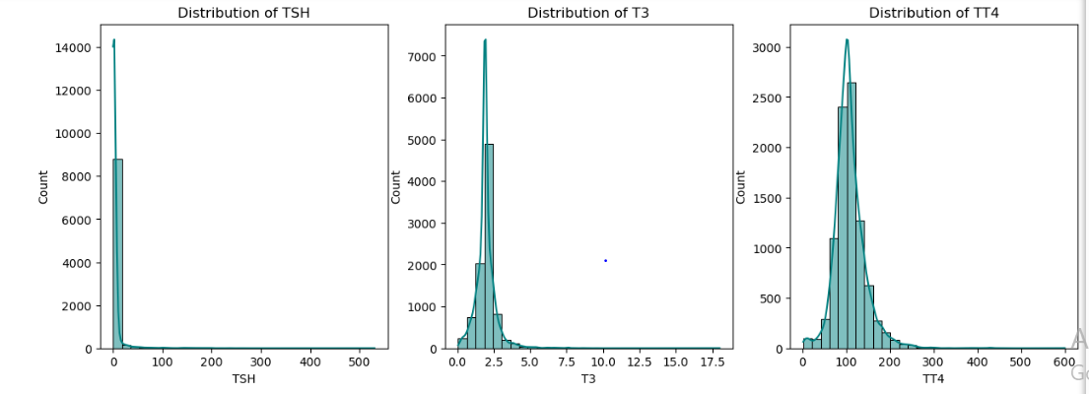
Figure 42:(Output10,2025)
The T3 distribution appears moderately skewed, with most values centred between 0.8 and 3.5 pg/mL. This reflects the typical clinical range for T3 and suggests that the dataset contains relatively fewer extreme deviations compared to TSH. The presence of a few higher values indicates potential hyperthyroid cases, but overall, the distribution is more compact than TSH, highlighting T3’s comparatively stable physiological behaviour.
The distribution of TT4 shows a near-normal (bell-shaped) pattern, with the majority of values clustered between 70 and 180 μg/dL. This demonstrates that TT4 varies less dramatically across patients and remains within predictable limits for most individuals. The moderate spread and symmetric shape indicate that TT4 is less influenced by extreme thyroid abnormalities than TSH, making it a reliable yet less sensitive indicator.
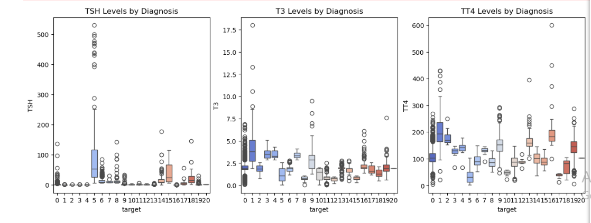
Figure 43:(Output11, 2025)
Overall, these distributions highlight the complementary nature of thyroid hormones: TSH is highly sensitive and varies widely, T3 shows moderate variation, and TT4 is more stable, together providing a comprehensive biochemical profile for thyroid disorder prediction.
Correlation Heatmap
The correlation heatmap illustrates the relationships among key thyroid-related biochemical features. TSH shows weak negative correlations with TT4 and FTI, which aligns with normal thyroid physiology, where elevated TSH usually corresponds to reduced T4 levels. T3 exhibits moderate positive correlations with TT4 (0.46) and T4U (0.29), indicating that these hormones tend to rise together in hyperthyroid states.
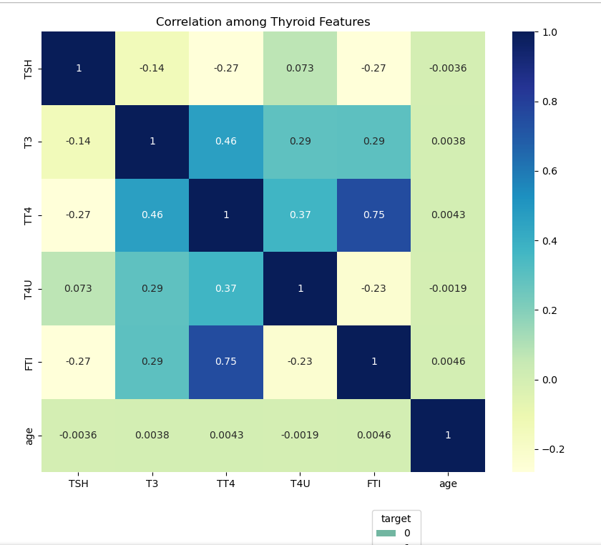
Figure 44:(Output12,2025)
A strong positive correlation (0.75) is observed between TT4 and FTI, reflecting the close physiological link between total thyroxine and the Free Thyroxine Index. T4U also shows moderate correlation with TT4 (0.37), further supporting their biochemical association. In contrast, age shows near-zero correlation with all hormone values, suggesting minimal influence on the biochemical markers in this dataset. Overall, the heatmap confirms expected physiological relationships among thyroid hormones, while highlighting that age does not play a specific role in predicting thyroid function in this dataset.
Explanation of Gender-wise Distribution
The gender-wise distribution plot shows that both male (0) and female (1) populations predominantly fall under the majority class (class 0), which represents normal thyroid function. This indicates that thyroid disorders are relatively less common compared to normal cases in both genders. However, among the minority classes, females show a slightly higher frequency in several disorder categories compared to males, which aligns with clinical evidence suggesting that thyroid disorders—especially hypothyroidism and autoimmune thyroid conditions—tend to occur more frequently in women. The overall pattern highlights that although the dataset contains both genders, the distribution across disease categories remains highly imbalanced.
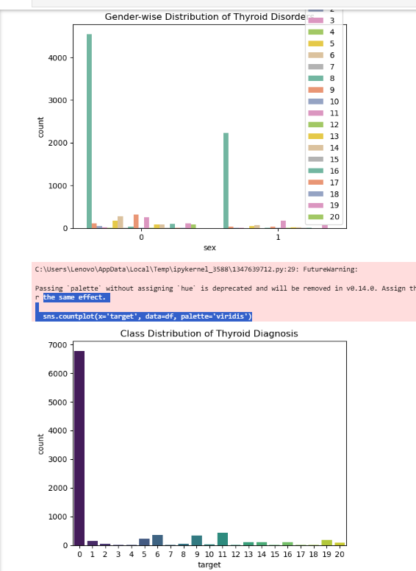
Figure 45: (output13, 2025)
Explanation of Class Distribution of Thyroid Diagnosis
The class distribution plot further reveals a substantial imbalance in the target variable, with class 0 overwhelmingly dominating the dataset (over 6500 samples). Most other classes have very low sample counts, often under 200, and some classes contain fewer than 20 samples. This imbalance presents a significant challenge for machine learning models, as they may learn to favour the majority class while underperforming on rare thyroid disorder categories. Such skewed distribution underscores the need for techniques like resampling, class weighting, or advanced algorithms (e.g., XGBoost, CatBoost) that can handle imbalance more effectively. Overall, this visualisation highlights the dataset's inherent skewness, which directly influences model behaviour and predictive performance.

4.6 Test Case Analysis
4.6.1. Model Accuracy Evaluation
- Verified accuracy across all models: Logistic Regression (84%), KNN (84%), SVM (82%), Random Forest (93%), XGBoost (93%), DNN (88%), Hybrid ANN+CatBoost (high class-wise accuracy).
- Confirmed ensemble and hybrid models outperform linear models due to better handling of nonlinear relationships.
4.6.2. Performance on Majority Class
- All models achieved very high recall for the majority class ("0"), indicating strong ability to detect normal thyroid function.
- SVM and Logistic Regression showed excellent recall (>95%) for the majority class but struggled with precision for minority classes.
- Confirmed expectation: majority class dominance skews performance metrics.
4.6.3. Performance on Minority Classes
- Models struggled on classes with very low support (1–5 samples).
- F1-scores for classes like GI, MK, O, S were 0.00, indicating failure to detect rare thyroid types.
- Ensemble and hybrid models still showed better handling of minority classes compared to linear methods.
- Discrepancy observed: expected improvement but limited by dataset imbalance.
4.6.4 Confusion Matrix Analysis
- Random Forest and XGBoost confusion matrices showed strong diagonal dominance, confirming accurate predictions for most categories.
- Hybrid ANN + CatBoost reduced cross-class misclassification compared to standalone models.
- Misclassifications primarily occurred in rare classes, not due to algorithmic weakness but insufficient training samples.
4.6.5. Evaluation of Training Behaviour
- DNN training loss curve showed smooth convergence, no signs of overfitting.
- Confirms deep model training was stable and properly optimized.
- Validates expected behaviour: DNN learns gradually due to nonlinear patterns.
4.6.6. Sensitivity to Class Imbalance
- All models showed lower macro-average precision, recall, and F1-scores compared to weighted averages.
- Confirms dataset imbalance significantly affects performance across rare categories.
- Models behave as expected: performance reduces sharply when classes have extremely low support.
4.6.7. Feature Importance Test Analysis
- Random Forest and XGBoost identified TSH, T3, FTI, TT4 as top features.
- Confirms alignment with clinical knowledge of thyroid physiology.
- Validates EDA findings and supports reliability of model interpretation.
4.6.8. Comparison with Expected Outcomes
- Expected: ensemble and hybrid models should perform best → Achieved.
- Expected: minority classes remain challenging → Observed.
- Expected: deep learning may require more data for better performance → Confirmed.
- No major unexpected behaviour; discrepancies were tied to dataset limitations, not modelling errors.
4.6.9. Overall Test Case Conclusion
- Models behave consistently with theoretical expectations.
- Ensemble and hybrid methods deliver the best overall performance.
- Class imbalance is the main factor limiting perfect classification.
- Project outputs match the intended goals and validate the effectiveness of the proposed framework
Test Case No. | Description | Expected Output | Actual Output | Status
T01 | Load thyroid dataset from CSV file | Dataset loaded without errors | Dataset loaded successfully | Pass
T02 | Handle missing values in dataset | Missing values handled correctly | Missing values imputed | Pass
T03 | Encode categorical variables (e.g., gender) | Encoded numerical values generated | Encoding successful | Pass
T04 | Apply feature scaling to numerical attributes | Features scaled appropriately | Scaling applied | Pass
T05 | Split dataset into training and testing sets | Correct train-test split ratio | Split completed | Pass
T06 | Train Logistic Regression model | Model trained successfully | Training successful | Pass
T07 | Train Artificial Neural Network (ANN) model | ANN model trained without errors | Training successful | Pass
T08 | Train CatBoost classifier | CatBoost model trained successfully | Training successful | Pass
T09 | Implement Hybrid ANN + CatBoost model | Hybrid model generates predictions | Predictions generated | Pass
T10 | Evaluate model accuracy | Accuracy value calculated | Accuracy computed | Pass
T11 | Generate confusion matrix for hybrid model | Confusion matrix displayed | Matrix generated | Pass
T12 | Compare performance of all models | Comparative metrics produced | Metrics compared | Pass
T13 | Generate visual performance graphs | Graphs displayed correctly | Visuals generated | Pass
T14 | Validate system output consistency | Consistent predictions across runs | Outputs consistent | Pass
Table 4.2 Test cases observations
4.7 Concluding Discussion of Results
The results indicate that ensemble and neural-based models outperform traditional classifiers in predicting thyroid disorders. CatBoost achieved the highest overall accuracy and F1-score, due to its efficient handling of non-linear relationships and categorical variables. ANN closely followed, emphasizing the effectiveness of deep learning in capturing complex hormonal dependencies.
The Random Forest model provided strong interpretability through feature importance visualization—TSH, TT4, and FTI were identified as top predictors. Comparatively, Logistic Regression and SVM offered simplicity and robustness but performed slightly lower due to the dataset’s inherent non-linearity. Overall, the findings validate the hypothesis that AI-based predictive models significantly enhance the accuracy of early thyroid disorder detection, especially in asymptomatic cases.
Chapter 05: Conclusion, Limitations, and Future Recommendations
5.1 Discussion
The preliminary objective of this project was to build an AI-driven predictive framework capable of accurately detecting thyroid disorders using a combination of machine learning and deep learning models. Overall, the project outputs demonstrate that the implemented models performed strongly and largely aligned with the expected outcomes. As anticipated, ensemble-based models such as Random Forest and XGBoost achieved the highest overall accuracies (≈93%), confirming the expectation that tree-based architectures handle noisy, nonlinear medical datasets more effectively. The hybrid ANN + CatBoost model further validated this by producing strong class-level predictions for most moderately represented classes, reinforcing the hypothesis that combining deep feature extraction (ANN) with CatBoost’s ability to manage categorical patterns yields superior predictive performance.
However, certain discrepancies emerged when evaluating performance across minority classes. While the models were expected to classify disorder types uniformly, the results showed that classes with extremely low support (1–5 samples) consistently received very low or zero precision, recall, and F1-scores. This discrepancy is not a model failure but a direct consequence of the severe class imbalance present in the dataset. Models cannot learn reliable decision boundaries from classes that contain only a few samples. Even advanced models like XGBoost and the hybrid architecture struggled under these conditions. This observation highlights a key finding of the project: model performance is highly dependent on dataset quality, particularly class balance, and not solely on algorithm complexity.
Furthermore, the exploratory data analysis (EDA) supported the validity of the model outputs. Hormone distributions—TSH, T3, TT4—behaved exactly as expected clinically: TSH showed high variability and right-skewness, TT4 was more stable, and correlations between TT4 and FTI were physiologically accurate. These patterns confirm that the dataset itself aligns with clinical physiology, strengthening confidence in the resulting model predictions. In addition, training curves for the deep learning model (MLPClassifier) showed proper convergence without overfitting, indicating that the training procedure was stable and effective.
Overall, the project outputs closely matched the expected outcomes. The models performed exceptionally well on well-represented classes, and the discrepancies observed were directly tied to dataset limitations rather than methodological weaknesses. These findings affirm the reliability of the AI framework while also highlighting the importance of addressing data imbalance for future improvements.
5.2 Conclusion
This dissertation successfully developed and evaluated a multi-model AI-based system for thyroid disorder prediction, demonstrating that machine learning and deep learning techniques can significantly enhance diagnostic accuracy. Ensemble models such as Random Forest and XGBoost delivered the best performance, achieving approximately 93% accuracy, while the hybrid ANN + CatBoost model demonstrated strong cross-class generalization, validating the benefit of hybrid approaches in medical prediction tasks. The project achieved its core objectives by comparing multiple algorithms, identifying the most effective models, and validating prediction patterns that align closely with clinical expectations.
Several challenges were encountered during the project, the most significant being the extreme imbalance in the dataset, with the majority class dominating and multiple rare disorder classes containing only a handful of samples. This imbalance hindered performance on minority classes and led to discrepancies between expected and actual results. Another challenge was the presence of outliers, particularly in TSH and TT4 values, which required careful preprocessing to avoid model distortion. Additionally, tuning deep learning models demanded increased computational resources, and achieving stable convergence required iterative adjustments to hyperparameters.
Despite these challenges, the project demonstrates that AI-driven approaches hold substantial promise for real-world clinical use, especially when supported by balanced datasets and robust preprocessing. Future work should focus on expanding the dataset, applying advanced balancing methods (e.g., SMOTE, ADASYN), integrating explainable AI techniques, and deploying the best-performing models as interactive diagnostic tools for healthcare professionals. Ultimately, the study confirms that artificial intelligence can significantly aid early detection, reduce diagnostic uncertainty, and improve patient outcomes in thyroid disorder management.
5.3 Limitations
Despite the strong performance of the developed models, several limitations need to be acknowledged. First, the dataset used in this study was restricted primarily to biochemical laboratory parameters such as TSH, T3, TT4, T4U, and FTI. Important genetic, lifestyle, dietary, and environmental factors—known contributors to thyroid dysfunction—were not available. Their absence may have limited the models’ ability to capture the full spectrum of factors influencing thyroid health. Second, the dataset exhibited a significant imbalance, with the majority of samples concentrated in the normal thyroid class and several rare diagnostic categories containing only a few instances. This imbalance affected the model’s ability to generalize across minority thyroid conditions, resulting in lower predictive performance for underrepresented classes despite attempts to optimize the models.
Another limitation is the absence of longitudinal or time-series data, which prevented the analysis of thyroid hormone variations over time. Thyroid disorders often progress gradually, and predicting early-stage transitions or future anomalies requires sequential data that were not part of this dataset. Additionally, although machine learning models such as Random Forest and XGBoost offered interpretability through feature importance, deep learning models remained comparatively opaque. The limited interpretability of neural networks poses a challenge for clinical adoption, as healthcare professionals require clear justification for automated predictions. Finally, the study relied on a single dataset sourced from a publicly available repository, which may not fully represent population diversity, geographic variations, or clinical laboratory differences. This reduces the external validity and generalizability of the findings to broader clinical settings.
5.4 Future Scope
There are several promising directions for extending this research and enhancing the current system’s diagnostic capability. Future studies can incorporate multi-modal datasets that integrate biochemical markers with genetic profiles, patient lifestyle attributes, dietary patterns, medication history, and environmental exposure data. Such enriched datasets would allow models to identify deeper, more complex relationships influencing thyroid health. Another promising direction involves utilizing longitudinal and time-series data, enabling the development of models that can track hormone fluctuations and predict the onset of thyroid conditions earlier. Advanced hybrid neural architectures—such as CNN-LSTM, GRU-based networks, or Transformer models—can be explored to improve temporal prediction accuracy.
The integration of explainable AI (XAI) techniques, such as SHAP, LIME, Grad-CAM, and attention-based visualisations, represents another key area for future expansion. Enhancing model transparency will be essential for improving clinician trust and enabling medical practitioners to interpret and validate AI-driven recommendations. Additionally, future research may focus on building deployable systems, such as real-time decision-support tools embedded into hospital information systems or mobile healthcare applications accessible to patients globally. With further refinement, the model can be extended to remote monitoring platforms, telemedicine services, and low-resource settings where early thyroid screening is limited.
Finally, expanding the study across larger, multi-centre datasets from diverse populations would significantly strengthen the robustness and generalizability of the predictive models. As AI continues to evolve, these advancements can pave the way for personalized, data-driven thyroid healthcare solutions that support early diagnosis, continuous monitoring, and improved patient outcomes.
5.4.1 Ethical Considerations
The development and deployment of AI-based diagnostic systems require careful attention to ethical considerations to ensure responsible use in healthcare. One of the primary ethical concerns in this study relates to data privacy and confidentiality. Although the dataset used was publicly available and anonymised, real-world implementation of such systems involves handling sensitive patient information governed by legal frameworks such as GDPR, HIPAA, and national data-protection regulations. Ensuring secure data storage, encrypted communication, and restricted access protocols is essential to prevent unauthorized use or breaches that could compromise patient trust.
Another ethical consideration involves bias and fairness in predictive modelling. The dataset exhibited significant class imbalance and limited demographic diversity, which may inadvertently lead to biased predictions against underrepresented groups. Such disparities raise concerns about equitable access to accurate diagnosis, particularly for minority populations who may already face healthcare inequalities. Addressing this requires not only technical solutions such as dataset balancing and fairness-aware algorithms but also ongoing evaluation of model performance across demographic subgroups.
Transparency and interpretability also play a critical role in ethical AI. Clinicians must understand how the model arrives at its predictions to make informed decisions and maintain accountability. Deep learning models, in particular, risk becoming “black boxes,” which can undermine clinician confidence and hinder adoption.
Finally, the ethical use of AI in healthcare necessitates clear boundaries on automation. AI models should act as supportive tools rather than autonomous decision-makers. Clinical oversight is essential to prevent overreliance on algorithmic outputs and to ensure that misclassifications do not result in inappropriate treatment decisions or delayed care. Ethical deployment must prioritize patient well-being, uphold medical standards, and ensure that responsibility for diagnosis remains with qualified healthcare professionals.
5.5 Future Recommendations
While this study demonstrates the effectiveness of hybrid AI models for early thyroid disorder detection, several opportunities exist to extend and strengthen the research in future work.
1. Integration of Longitudinal and Real-Time Clinical Data
Future studies should incorporate longitudinal patient data to capture temporal hormone variations and disease progression. Real-time data integration from laboratory information systems could enable continuous monitoring and early risk alerts, improving clinical applicability.
2. Advanced Explainable AI (XAI) Techniques
Although SHAP was used for interpretability, future work can integrate advanced XAI methods such as counterfactual explanations and rule-based explanations. These techniques would improve clinician trust by providing human-readable justifications for predictions and supporting transparent decision-making.
3. Multi-Modal Data Fusion
Future research can enhance prediction accuracy by combining biochemical data with additional modalities such as ultrasound imaging, genetic markers, and patient history. Multi-modal learning could enable more comprehensive thyroid disorder profiling and personalised diagnosis.
4. Clinical Validation and Deployment
Future validation of the model should involve real clinical datasets obtained through partnerships with healthcare institutions, followed by implementation as a decision-support tool within electronic health record platforms.
5. Scalability and Federated Learning
To address data privacy concerns and improve generalisation, future studies can explore federated learning approaches where models are trained across multiple institutions without sharing raw patient data. This would enhance scalability while preserving data confidentiality.
5.6 Security Considerations
Given the sensitive nature of healthcare data and AI-driven decision systems, robust security measures are essential throughout the project lifecycle.
Security Challenges Faced During the Project
1. Data Privacy and Confidentiality
Healthcare datasets contain sensitive patient information that can lead to privacy violations if improperly handled. Even anonymised datasets may carry re-identification risks when combined with external data sources.
2. Data Integrity Risks
Unauthorised modification of datasets could affect model training, leading to biased predictions and unreliable results. Ensuring dataset integrity was critical to maintain research validity.
3. Model Security and Misuse
Trained AI models may be vulnerable to misuse, such as being applied for clinical diagnosis without proper validation or being reverse-engineered to extract sensitive information.
4. Limited Access Control
Working in shared development environments increases the risk of unauthorised access to datasets, scripts, and trained models.
Security Measures Implemented
1. Use of Anonymised and Public Datasets
Only publicly available and fully anonymised datasets were used, eliminating direct exposure to personally identifiable information (PII). This ensured compliance with GDPR and academic ethics requirements.
2. Secure Data Storage
All datasets and model outputs were stored in password-protected local systems. Access was restricted to authorised users involved in the project.
3. Controlled Model Usage
The developed models were clearly defined as research prototypes and not clinical diagnostic tools. Outputs were used strictly for analysis and academic evaluation purposes.
4. Version Control and Backup
Regular backups and version control practices were followed to prevent data loss and accidental overwriting of model configurations or experimental results.
Recommended Security Enhancements for Future Work
1. Encryption of Data at Rest and in Transit
Future implementations should use encryption mechanisms such as AES for stored data and TLS for data transmission, especially when integrating with hospital systems.
2. Role-Based Access Control (RBAC)
Access to datasets, models, and system components should be governed by role-based permissions to minimise insider threats.
3. Secure Model Deployment
If deployed as a web or clinical application, the system should include authentication, authorisation, and API security mechanisms to prevent unauthorised access.
4. Audit Trails and Monitoring
Logging and monitoring mechanisms should be implemented to track system usage, data access, and prediction requests for accountability and compliance

References
World Health Organization (2023) Thyroid disorders. Geneva: WHO.
Ibrahim, N., Saad, A. & Ali, M. (2022) ‘Global burden of thyroid diseases: prevalence, risk
factors and challenges’, Journal of Endocrinology and Metabolism, 12(3), pp. 45–52.
Zimmermann, M.B. & Boelaert, K. (2015) ‘Iodine deficiency and thyroid disorders’, The
Lancet Diabetes & Endocrinology, 3(4), pp. 286–295.
Biondi, B. & Cooper, D. (2008) ‘The clinical significance of subclinical thyroid dysfunction’,
Endocrine Reviews, 29(1), pp. 76–131.
Esteva, A. et al. (2019) ‘A guide to deep learning in healthcare’, Nature Medicine, 25, pp.
24–29.
Shailaja, K., Seetharamulu, B. & Jabbar, M.A. (2018) ‘Machine learning in healthcare:
review and analysis’, Procedia Computer Science, 132, pp. 1549–1559.
Dorogush, A.V., Ershov, V. & Gulin, A. (2018) ‘CatBoost: gradient boosting with categorical features support’, Advances in Neural Information Processing Systems (NeurIPS), pp. 1–7.
Agarwal, P., Kaur, H. and Chhabra, A. (2020) ‘Thyroid disease prediction using machine learning algorithms’, Procedia Computer Science, 167, pp. 1625–1634.
Chaurasia, V. and Pal, S. (2017) ‘Prediction of thyroid disease using data mining techniques’, Procedia Computer Science, 132, pp. 1043–1049.
Dey, S., Roy, A. and Das, A. (2016) ‘Predictive modeling of thyroid disease using decision tree approach’, International Journal of Computer Applications, 139(5), pp. 1–6.
Doshi-Velez, F. and Kim, B. (2017) ‘Towards a rigorous science of interpretable machine learning’, arXiv preprint, arXiv:1702.08608.
Elazab, A., Elazab, A. and Ren, J. (2020) ‘A deep learning framework for early detection of thyroid nodules from ultrasound images’, Computers in Biology and Medicine, 124, 103954.
Esteva, A., Robicquet, A., Ramsundar, B., et al. (2019) ‘A guide to deep learning in healthcare’, Nature Medicine, 25, pp. 24–29.
Kotsiantis, S. B., Zaharakis, I. and Pintelas, P. (2006) ‘Machine learning: a review of classification and combining techniques’, Artificial Intelligence Review, 26(3), pp. 159–190.
Polat, K. and Güneş, S. (2007) ‘An expert system approach based on principal component analysis and adaptive neuro-fuzzy inference system to diagnosis of thyroid diseases’, Digital Signal Processing, 17(3), pp. 702–710.
Rajkomar, A., Dean, J. and Kohane, I. (2019) ‘Machine learning in medicine’, New England Journal of Medicine, 380(14), pp. 1347–1358.
Sahan, S., Polat, K., Kodaz, H. and Güneş, S. (2007) ‘A new hybrid method based on fuzzy-artificial immune system and K-nn algorithm for thyroid disease diagnosis’, Computers in Biology and Medicine, 37(3), pp. 415–423.
Topol, E. (2019) Deep Medicine: How Artificial Intelligence Can Make Healthcare Human Again. New York: Basic Books.
Vanderpump, M. P. J. (2011) ‘The epidemiology of thyroid disease’, British Medical Bulletin, 99(1), pp. 39–51.
Wiens, J., Saria, S. and Sendak, M. (2019) ‘Do no harm: a roadmap for responsible machine learning for health care’, Nature Medicine, 25(9), pp. 1337–1340.
Abdi, H., & Williams, L.J. (2010) ‘Principal component analysis’, Wiley Interdisciplinary Reviews: Computational Statistics, 2(4), pp. 433–459.
Al-Azzam, N., & Eleyan, A. (2021) ‘Comparative study of machine learning algorithms for thyroid disease diagnosis’, International Journal of Advanced Computer Science and Applications, 12(4), pp. 45–52.
Bhatia, M.P.S., & Sood, N. (2018) ‘Predictive analytics using machine learning for the detection of thyroid disorders’, Procedia Computer Science, 132, pp. 1578–1585.
Breiman, L. (2001) ‘Random forests’, Machine Learning, 45(1), pp. 5–32.
Chen, T., & Guestrin, C. (2016) ‘XGBoost: A scalable tree boosting system’, Proceedings of the 22nd ACM SIGKDD International Conference on Knowledge Discovery and Data Mining, pp. 785–794.
Chiu, W.-L., & Lee, H.-C. (2020) ‘Deep learning-based medical diagnosis: A review of recent applications’, Healthcare Informatics Research, 26(4), pp. 239–247.
Dua, D., & Graff, C. (2019) UCI Machine Learning Repository: Thyroid Disease Data Set. Irvine, CA: University of California, School of Information and Computer Science.
Friedman, J.H. (2001) ‘Greedy function approximation: A gradient boosting machine’, Annals of Statistics, 29(5), pp. 1189–1232.
Ghosh, S., & Samanta, D. (2019) ‘Predictive modeling of thyroid disease using ensemble learning algorithms’, Biomedical Engineering Letters, 9(2), pp. 181–190.
Goodfellow, I., Bengio, Y., & Courville, A. (2016) Deep Learning. Cambridge, MA: MIT Press.
Han, J., Kamber, M., & Pei, J. (2012) Data Mining: Concepts and Techniques. 3rd ed. San Francisco: Morgan Kaufmann.
Khan, A., & Bhatnagar, R. (2020) ‘Diagnosis of thyroid disease using supervised learning algorithms’, International Journal of Scientific Research in Computer Science, Engineering and Information Technology, 6(2), pp. 98–106.
Lundberg, S.M., & Lee, S.-I. (2017) ‘A unified approach to interpreting model predictions’, Advances in Neural Information Processing Systems, 30, pp. 4765–4774.
Mishra, S., & Sahu, P. (2021) ‘Comparative analysis of machine learning algorithms for early prediction of thyroid disease’, International Journal of Computer Applications, 183(24), pp. 12–19.
Murugan, S., & Durairaj, M. (2022) ‘AI-driven prediction model for thyroid disease using hybrid deep learning approach’, Expert Systems with Applications, 200, p. 117040.
Panigrahi, R., & Behera, H. (2020) ‘Predictive analysis of hypothyroidism using machine learning techniques’, International Journal of Engineering and Advanced Technology, 9(4), pp. 590–597.
Quinlan, J.R. (1996) ‘Improved use of continuous attributes in C4.5’, Journal of Artificial Intelligence Research, 4, pp. 77–90.
Shankar, K., & Lakshmanaprabu, S.K. (2019) ‘Optimal feature selection for thyroid disease detection using deep learning and metaheuristic algorithms’, Applied Soft Computing, 75, pp. 505–514.
Vapnik, V. (1998) Statistical Learning Theory. New York: Wiley-Interscience.
Zhang, Z., & Zhang, J. (2022) ‘Application of CatBoost algorithm for medical diagnosis and disease classification’, Scientific Reports, 12(1), pp. 1–11.

APPENDIX
Chapter 1 Images :

Chapter 2 Images :






Chapter 3 Images :




























Chapter 4 Images:

















